Mission Action Plan 2023

As heralds of God’s Kingdom, who seek its unfolding glory- blessing, renewing and restoring the whole of creation- we are pilgrims together in the communities of Severn Loop, journeying onwards in faith, hope and love.

Whether it’s through our schools, our social networks, our nursing home, our Forest Church, the privilege of our occasional offices, our Sunday gatherings or just the prosaic business of everyday life, we are committed to deepening our understanding of the divine love in which we are all held and to allow that love to guide us as we live sacramentally.

Our sense of collective identity at Severn Loop Parishes continues to strengthen, and we are looking to work together more effectively and strategically in key areas of mission. Our MAP is designed to reflect this aspect of our common life together, but we do take mission seriously in all our communities, recognising the uniqueness and distinctiveness of each. Therefore, the first part of our plan focuses on group-wide priorities and strategy, and the second part takes a particular look at individual churches and their needs, challenges and opportunities.
The decision to focus on the general first is deliberate: it is a recognition of our desire to understand better how God is forming us together into the Body of Christ; how all that we do is a witness to the Gospel; and how the Spirit turns our life and worship into effective mission. As Romans 12: 4-6 reminds us:
‘For just as each of us has one body with many members, and these members do not all have the same function, so in Christ we, though many, form one body, and each member belongs to all the others. We have different gifts, according to the grace given to each of us.’
Our MAP is structured in terms of the diocesan priorities of Discipleship, Vocation and Evangelism. In Severn Loop we have translated this into our own strap-line- Know the Story, Share the Story, Live the Story.
We will review/ reflect on our MAP in both PCC and Wardens’ meetings, at least annually.
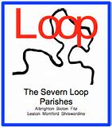

Discipleship- how we Live the Story across Severn Loop
Now- Celebrate with us that….
The introduction of twice-yearly Wardens’ Meetings has helped us continue to work better together, as do events and services that we share within the rhythm of the year.
We enjoy worshipping together on 5th Sundays, and we have ventured into pastures new with a sung Eucharist for Candlemas and a (scratch-choir led) sung Evensong.
Sunday@6 (our weekly Zoom service) is well-established and includes people from across the whole Loop.
The peripatetic nature of Forest Church means that we enjoy visiting different parts of the parish together, for worship and fellowship.
Before the Pandemic, we had the blessing of annual coach trips to Cathedral cities, including Choral Evensong.
We have well-established regular modes of communication- weekly emails, the monthly Loop newsletter, our website and our Facebook page.
We have a cyclical prayer diary available for people to use in their homes.
Quarterly 24/7 prayer events continued virtually throughout the Pandemic.
We are regularly in our two Church schools, joining the children for worship and being alongside them in their faith.
Our monthly service at Isle Court Nursing Home is thriving!
The coming year- pray for our immediate plans to….
Make better use of our rural setting in engaging with God, possibly through guided walks and outdoor services in our churchyards.
Introduce a weekly midweek Morning Prayer service, probably on Zoom.
To establish a rhythm of Experience Days for Bomere School and Spirituality Days at Bicton School.
Get better at saying thank-you! There are many hidden hands who help maintain our churches- it would be good to find a regular way to show our appreciation.
Continue to develop 24/7 prayer, making it a termly event.
In the years ahead- encourage us as we….
Continue to consider how our environment speaks into our spiritual journey- especially with respect to the river- whose meandering loop links us together.
Continue our commitment to engaging people of all ages, particularly young adults.
Think about how to introduce occasional worship services targeted at different demographic groups, or on different themes and styles.
Vocation- how we Know the Story across Severn Loop
Now- Celebrate with us that….
Rotas and roles are filled- people offer gifts sacrificially in so many ways to sustain the life and ministry of our churches, whether it be through cleaning, gardening, providing refreshments, reading, welcoming, decorating the church, maintaining the building, or any number of hidden acts of service.
Through our work in schools, we are learning from each other, being awakened to the work of God in our lives and deepening our knowledge of who God has created us to be.
Through the work co-ordinated by our Pastoral Care Minister, we are committed to showing those vulnerable members of our community that they are loved by God and by us.
Our Remembering with Love service is well-established and demonstrates our response to God’s love by showing love to those who grieve.
Our sense of Christian heritage is expressed through some of our ancient buildings- our use of the church and churchyard at Battlefield is an example of this.
Our vocation to stewarding creation is expressed through Forest Church, the newly developed ‘wild’ areas in some of our churchyards and our commitment to the Eco Church initiative.
We are continuing to develop our approach to baptism by continued contact with families through Forest Church and have been encouraged by those attending from this demographic.
We have been working on our understanding and commending of personal stewardship (of money, skills, time and resources), and have made this a focus in Parish magazine articles and information in the pews.
The coming year- pray for our immediate plans to….
Develop Forest Church further by seeking a more predictable rhythm and finding some new venues.
Continue to have fun! Recognising the joy of the gospel by continuing to do social things together!
Reintroduce/ introduce some specific, themed worship services- for example Healing services, Pet Services, Churchyard services and informal worship. Some of these could work as part of Forest Church.
Continue our commitment to helping those living with dementia and those who care for them feel welcome in our church services, so they can be valued as people with unique gifts, created for worship. All churches and CofE schools in Severn Loop hold a Dementia Friendly Certificate from the diocese.
Develop regular periods of study groups and Quiet Days as opportunities to deepen our understanding of who God has created us to be.
Provide regular worship training for all involved in our Sunday services (as per the Diocesan regulations).
Reintroduce the annual coach trip.
Remember the importance fellowship and fun! So, reintroduce some social/ musical evenings.
Consider doing a study course together.
In the years ahead- encourage us as we….
Think about how to extend our corporate gift of hospitality, as a means of inviting more people to recognise and offer the gifts God has given them- maybe by hosting a coffee and cake stall in various locations, or a mending workshop/ skill-sharing opportunity.
Consider how to build a community of prayer that goes beyond specific occasions and events.

Evangelism- how we Share the Story across Severn Loop
Now- Celebrate with us that….
Forest Church is well-established, popular, and attracts people of all ages, many of whom do not attend church on Sunday mornings. Through trying different venues, we’ve also got to know members of the farming community better.
We have strong relationships with our two primary schools (Bomere and Bicton) through Open the Book and church members serving on the governing body.
We have had people turn up to services purely through seeing them advertised on our website or Facebook page.
24/7 prayer is open to all as an invitation to explore faith.
We have a prayer-shawl ministry and a tradition of giving Christmas cards created by the local schoolchildren to those who receive Home Communion and regular visits, to help them feel connected to us, and to our Christian hope.
We enjoy regular opportunities to share the gospel through baptisms, weddings and funerals.
We are regular contributors to parish magazines, which gives us the opportunity to share our story in a local context.
Our many open churchyards are a place of peace and comfort to our community- they are well-loved, well-tended and speak of God’s enduring love to those who walk the path of grief. In some cases, they also commend the Gospel through their biodiversity and story.
We have enjoyed singing carols in the Red Lion in Bomere, 1403 and at Preston Gubbals.
We have begun to work more closely with the Churches Conservation Trust to include prayer prompts and information about services at both Preston Gubbals and Battlefield.
A caregiver and pre-schooler group has begun in the Mission Church on Tuesday mornings- providing an opportunity for a ministry of hospitality. This also functions partly as a warm space as donations are invited, but there is no charge for the use of the building.
The coming year- pray for our immediate plans to….
Send out an invitation for Confirmation to children in years 5/6 in our local schools, and to the community in general. We hope to have a service in the Autumn term.
Broaden our pastoral support by providing points of regular contact throughout the year- particularly looking at how we can follow-up links from the occasional offices.
Take a fresh look at our ‘public face’- including the website and our notice boards outside churches.
Look for further opportunities to offer prayer and words of comfort in our churchyards and church porches.
Host a Farmers’ Forum on behalf of the Diocese- a place where those working in agriculture and those with an interest in environmental issues can meet in friendship and develop understanding.
Make the most of the opportunities festivals bring- particularly Easter, Harvest and Christmas. For example, we hope to build on this year’s Carol Singing round the Loop by reintroducing the Carol Service at Preston Gubbals.
Make the frequency of Forest Church predictable, possibly linking it to festivals.
To get more involved in the Ride and Stride initiative.
In the years ahead- encourage us as we….
Creatively consider how we continue to commend the Gospel through our engagement with the local environment.
Consider how to speak the message of hope in a culture that struggles to deal with death- possibly by running Gravetalk and discerning an appropriate venue.
Continue to develop relationships with local businesses and other educational establishments around Severn Loop.
Develop family-orientated pilgrimage walks around the Loop- possibly from church to church and including contemplative spaces in churchyards.
Welcome people’s passions into the church building- host events in church that link to the interests in our community (for example, model railways, flower festivals, wedding exhibitions).
Where safe and appropriate, consider opening our churches on set days/ times.

Our Churches
Albrighton
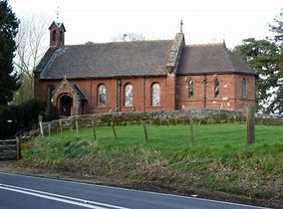
Our friends say:
- We are very welcoming and friendly.
- We have provided an excellent car park!
- We are good at making connections with the hotels, and our sung Evensong was particularly lovely.
- The church is an intimate space for worship and is stunningly beautiful.
- We work hard!

Celebrate with us:
- that we regularly advertise our services in the local hotels and this has drawn people in, particularly at Christmas.

Pray for our immediate plans:
- to hold a pet service on local farmland.

+++++++++++++++++++++++++++++++++++++++++++++++++++++++++++++++++++++++++++++++++

Bicton
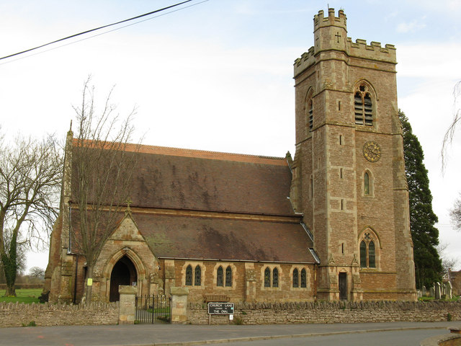
Our friends say:
- We are a friendly church, welcoming and inclusive.
- We are very flexible and easy-going.
- They appreciate our cake-making skills!
- They enjoy our Pet Service and the Teddy Bear Parachute Drop.
- We have strong links with children through the school Open the Book assemblies.

Celebrate with us:
- that our monthly coffee mornings are a place of welcome and encouragement.
- that we have a local home group.

Pray for our immediate plans:
- to reintroduce our Pet Service this September.
- to hold a Hymns and Pimm’s event in the summer.
- to open the church two days a week.
- to consider ‘lighting for loved ones’ at Christmas, and to develop our card ministry.

++++++++++++++++++++++++++++++++++++++++++++++++++++++++++++++++++++++++++++++++++

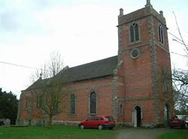
Fitz
Our friends say:
- The church is peaceful.
- We are visitor-friendly, welcoming and warm!
- We provide lovely hospitality and good food.
- We have a great village hall.
- We are happily unique.
- We have some brilliant local musicians who make our seasonal services special.
- We have a beautiful church building.
- The Festival of Remembrance is lovely.

Celebrate with us:
- that we have had some really encouraging family and seasonal services.
- our social events are well-attended.

Pray for our immediate plans:
- to reintroduce the village fete.
- to establish a rhythm of social and church events throughout the year.

++++++++++++++++++++++++++++++++++++++++++++++++++++++++++++++++++++++++++++++

Leaton (with Bomere Heath Mission Church)
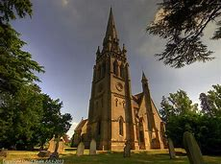
Our friends say:
- They enjoy the Remembering with Love service.
- We are welcoming, hospitable and stay in touch with people.
- They appreciate anniversary cards for baptism families.
- They appreciate Open the Book and links with the school.
- We are good at inviting people in, especially to Stepping Out Cafe.
- We care for the bereaved.
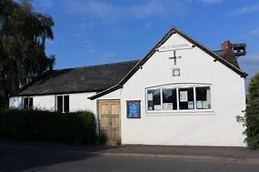
- We have good ecumenical links.
- Leaton is a beautiful church which is very well-maintained.
- The Mission Church is warm, intimate and friendly.

Celebrate with us:
- our Stepping Out Cafe is a place of warmth and welcome.
- we have a local home group.
- our social events are well-supported.

Pray for our immediate plans:
- to build on our Forest Church, caregivers and babies group and school contacts in creative ways.
- to explore how we can meet the desire for opportunities to pray together and take part in some discipleship courses.
- To continue to consider how to meet the pastoral needs of our community- we have made progress with this with our new Coffee and Play group, which functions as a warm space.

+++++++++++++++++++++++++++++++++++++++++++++++++++++++++++++++++++++++++++++

Montford
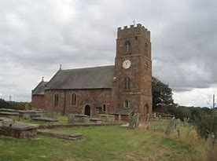
Our friends say:
- We have a real country church atmosphere.
- We have a relaxed ethos (but are driven!) and are welcoming.
- We practise good hospitality – with lots of cake!
- Our seasonal dioramas are lovely.
- We get involved in the community- with entertainment, events, and the panto.
- We do well to convene a Choir at Christmas!

Celebrate with us:
- that our dioramas are a creative way of sharing our Christian story.
- that our seasonal services are really well-supported by the community.
- that we have hosted Forest Church in our area.

Pray for our immediate plans:
- to talk with other churches in the Loop about using our churchyards for prayer and contemplation walks.

+++++++++++++++++++++++++++++++++++++++++++++++++++++++++++++++++++++++++++++++++

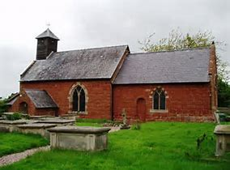
Shrawardine
Our friends say:
- We have a stunning location and a beautiful church.
- We are friendly, outgoing people who always provide a warm welcome.
- Jane’s window is very special.
- The Easter sunrise worship is well-loved.
- ‘The Space’ has a tranquil atmosphere and we have run some good Quiet Days.
- Our community involvement is appreciated- coffee mornings, craft activities and the panto.

Celebrate with us:
- that we are committed to being involved in the wider life of the community as a means of sharing our story.

Pray for our immediate plans:
- to add prayers onto the back of our giving cards so that those visiting can take a prayer to read.
- to begin developing a Quiet Day ministry, to include consideration of inviting young people from urban areas.
- To be creative about how we deal with the need for a toilet!

