Interim Priest-in-Charge: The Revd Hannah Lins
07736 012011 revhannahlins@gmail.com
Assistant Priest: The Revd Peter Allan
www.severnloopparishes.org.uk 01939 290048 pallan412@gmail.com
Lay Pastoral Minister: Mrs Joyce Jagger
Sharing the Light in the Loop 01743 298285 weekly worship 07802 695954 pearhill1@outlook.com
Daily Hope – the national service 0800 804 8044
Loop Special – October 2021
Weekly Collects, Readings and Reflection are on the website (see above.)

Forest Church

We had a brilliant time at our first Forest Church since before the pandemic! People of all ages attended (32 in all) and we are deeply grateful to Edward Tate for hosting our time together. There is a small patch of consecrated ground on the Isle Estate, and though we were unaware of it at the time, our little worship service was possibly the first service to be held on that site in 500 years!

Our next Forest Church is 21st November, 3pm. This will be Advent themed. Location details to follow, but for now do save the date!

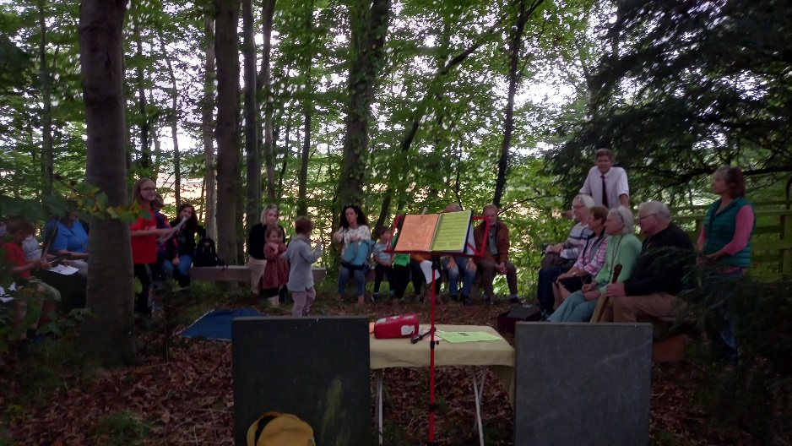
Our service in the woods

The Mission Church is open!

It was a joy to welcome worshippers back into the Mission Church in Bomere for two Eucharistic services per month – it’s been very special to be once again gathering in the heart of the village.

Remembering with Love

Our annual Remembering with Love service will be on the 31st October, 3pm at Leaton Church. Please email Hannah (revhannahlins@gmail.com) with any names of loved ones you would like to be remembered.

Readings for October

Although we will continue to provide weekly readings and the reflection by email, we’re also going to include the readings for each month in the Loop from now on. We’re mindful that most of us are back in church now, so there is no need to print out readings and deliver them week by week. If you are unable to get to church, and don’t have access to the internet, then the references below will enable you to look up the readings in your bible, and the phoneline (01743 298285) is also available- it always includes one of the readings and that week’s reflection.

HARVEST SERVICE READINGS | Psalm 126 | Joel 2.21-27 | Matthew 6.25-33
Sun 3 October  18th after Trinity | Psalm 26 | Hebrews 1.1-4; 2.5-12 | Mark 10.2-16
Sun 10 October  19th after Trinity | Psalm 22.1-15 | Hebrews 4.12-16 | Mark 10.17-31
Sun 17 October  20th after Trinity | Psalm 104.1-10,26,35c* | Hebrews 5.1-10 | Mark 10.35-45
Sun 24 October  21st after Trinity | Psalm 34.1-8,19-22 | Hebrews 7.23-28 | Mark 10.46-52
Sun 31 October  All Saints | Psalm 24.1-6 | Revelation 21.1-6a | John 11.32-44
Sun 7 Nov  3rd before Advent | Psalm 62.5-12 | Hebrews 9.24-28 | Mark 1.14-20

Harvest

Montford and Shrawardine have already had their celebration, but the rest of us will be marking Harvest this month. If you are coming along to one of our festival services, do please consider bringing a donation for the foodbank. All items must be non-perishable and can include toiletries and household products. The website is regularly updated with a list of things that are in particularly short supply- do take a look- Shrewsbury Food Bank — BARNABAS COMMUNITY PROJECTS.

Do you remember last year? We made a film- if you want a trip down memory lane, the link still works!

Severn Loop Harvest Celebration - YouTube

A date for your diary

Fitz is holding a Festival of Remembrance with the Yeoman Singers:
14th November, 5.30pm, Fitz church
All welcome!

SUNDAY SERVICES FOR OCTOBER
For Your Prayers
- The preparations for COP26 and the collective courage to turn from harmful ways that are destroying the natural world.
- Our local schools, who are navigating very challenging circumstances with high Covid levels amongst children and young people.
- For all working in the supply chain, delivering and distributing goods.
- The family and friends of Thelma Leddington, a member of our Leaton congregation, who died last month. RIP.
- The appointment process (see below).

Appointment process for the new
Priest-in-Charge
Please keep this process in your prayers, and rest assured that it is progressing. Parish Reps will be meeting with the Bishop and the Assistant Rural Dean this month.

Annual Leave
Hannah will be on Annual Leave from the 25th-28th October.

OTHER WAYS TO WORSHIP ON SUNDAYS
SUNDAY AT SIX 6 pm via Zoom – email Peter or Hannah to receive the link.
SHARING THE LIGHT IN THE LOOP
Our own weekly phone line worship – see top of this page for the local number to call.
DAILY HOPE – national phone line, see number above.
LICHFIELD CATHEDRAL
www.lichfield-cathedral.org 10.30 am Eucharist

SUNDAY 3 OCTOBER- 18th after Trinity
Albrighton 9.15 am Harvest Communion
Bicton 11 am Harvest Communion
Bomere No service
Fitz 9.30am HC BCP
Leaton 10.45 am Harvest Communion
Montford No service
Shrawardine 9.30 am Morning Worship

SUNDAY 10 OCTOBER- 19th after Trinity
Albrighton No service
Bicton 11am Morning Worship
Bomere 9am Holy Communion
Fitz No service
Leaton 10.45am Morning Worship
Montford 9.30am Holy Communion
Shrawardine 11am Holy Communion

SUNDAY 17 OCTOBER- 20th after Trinity
Albrighton 9.15am Morning Worship
Bicton 11am Holy Communion
Bomere No service
Fitz 6.30pm Harvest Festival
Leaton 10.45am Holy Communion
Montford 9.30am Morning Worship
Shrawardine No service

SUNDAY 24 OCTOBER- 21st after Trinity
Albrighton No service
Bicton 11am Morning Worship
Bomere 9am Holy Communion
Fitz No service
Leaton 10.45am Morning Worship
Montford 9.30am Holy Communion
Shrawardine 11am Holy Communion

SUNDAY 31 OCTOBER- ALL SAINTS
Bicton 10.30 am United Service

Leaton 3pm Remembering with Love

SUNDAY 7 NOVEMBER- 3rd before Advent
Albrighton 9.15 am Holy Communion
Bicton 11 am Holy Communion
Bomere No service
Fitz 9.30am HC BCP
Leaton 10.45 am Holy Communion
Montford No service
Shrawardine 9.30 am Morning Worship

