COLLECT, READINGS AND REFLECTION
SUNDAY 16 JANUARY 2022- 2nd of Epiphany

COLLECT

Eternal Lord,
our beginning and our end:
bring us with the whole creation
to your glory, hidden through past ages
and made known in Jesus Christ our Lord. Amen.

Psalm 36: 5-10
5 Your love, O Lord, reaches to the heavens ♦
and your faithfulness to the clouds.
6 Your righteousness stands like the strong mountains,
your justice like the great deep; ♦
you, Lord, shall save both man and beast.
7 How precious is your loving mercy, O God! ♦
All mortal flesh shall take refuge
under the shadow of your wings.
8 They shall be satisfied with the abundance of your house; ♦
they shall drink from the river of your delights.
9 For with you is the well of life ♦
and in your light shall we see light.
10 O continue your loving-kindness to those who know you ♦
and your righteousness to those who are true of heart.

1 Corinthians 12: 1-11

Spiritual Gifts
12 Now concerning spiritual gifts,^{[a]} brothers and sisters,^{[b]} I do not want you to be uninformed. ² You know that when you were pagans, you were enticed and led astray to idols that could not speak. ³ Therefore I want you to understand that no one speaking by the Spirit of God ever says ‘Let Jesus be cursed!’ and no one can say ‘Jesus is Lord’ except by the Holy Spirit.
⁴ Now there are varieties of gifts, but the same Spirit; ⁵ and there are varieties of services, but the same Lord; ⁶ and there are varieties of activities, but it is the same God who activates all of them in everyone. ⁷ To each is given the manifestation of the Spirit for the common good. ⁸ To one is given through the Spirit the utterance of wisdom, and to another the utterance of knowledge according to the same Spirit, ⁹ to another faith by the same Spirit, to another gifts of healing by the one Spirit, ¹⁰ to another the working of miracles, to another prophecy, to another the discernment of spirits, to another various kinds of tongues, to another the interpretation of tongues. ¹¹ All these are activated by one and the same Spirit, who allots to each one individually just as the Spirit chooses.

John 2: 1-11

The Wedding at Cana
2 On the third day there was a wedding in Cana of Galilee, and the mother of Jesus was there. ² Jesus and his disciples had also been invited to the wedding. ³ When the wine gave out, the mother of Jesus said to him, ‘They have no wine.’ ⁴ And Jesus said to her, ‘Woman, what concern is that to you and to me? My hour has not yet come.’ ⁵ His mother said to the servants, ‘Do whatever he tells you.’ ⁶ Now standing there were six stone water-jars for the Jewish rites of purification, each holding twenty or thirty gallons. ⁷ Jesus said to them, ‘Fill the jars with water.’ And they filled them up to the brim. ⁸ He said to them, ‘Now draw some out, and take it to the chief steward.’ So they took it. ⁹ When the steward tasted the water that had become wine, and did not know where it came from (though the servants who had drawn the water knew), the steward called the bridegroom ¹⁰ and said to him, ‘Everyone serves the good wine first, and then the inferior wine after the guests have become drunk. But you have kept the good wine until now.’ ¹¹ Jesus did this, the first of his signs, in Cana of Galilee, and revealed his glory; and his disciples believed in him.

A Reflection from Hannah….
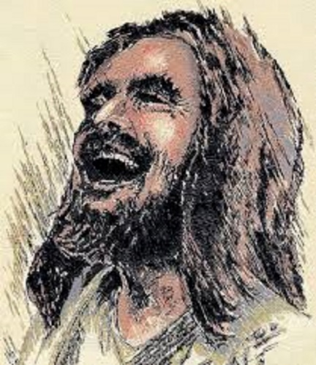
This image is called ‘Laughing Jesus’. What do you think? Of course our faith is a serious thing; it’s the home of our ultimate hope, gives meaning to the cosmos, sustains us in love… but perhaps we can sometimes be a bit serious about it.

This image of Jesus with head thrown back in a belly-laugh helps us in a similar way to the account of the wedding at Cana in our Gospel reading. In both cases we are reminded that joy, fun and delight are the stuff of Christ and an integral part of who we are. Great saints remind us of that too- like Archbishop Tutu, who had such a memorable and infectious giggle. But sadly, the stereotype of a Christian today is more likely to describe someone dour, solemn and humourless.

The context for Jesus’ first miracle- his first act that draws gasps of amazement and unsteadies everything- is a rather far-gone wedding party, where the simple fact that the wine has run out lets us know that it’s not a place of sobriety and dignity, but of raucous celebration, energy, joy and dancing. Jesus is in the thick of the good things that we celebrate.

The turning of water into wine is what John describes as the ‘first sign’ and it is about lavish hospitality, lightness and enjoyment- these are things of the Kingdom of God. So when we are tempted to take Jesus (and ourselves) a bit too seriously, noticing only the suffering servant, the challenging teacher, and forgetting the inevitable smiling and giggling and joking that would also have been part of showing us what the Kingdom of God is about, the message and the position of this miracle in the Gospel of John provides an important counterpoint.

The ‘first sign’ is a party, and it’s also a glimpse of the life of Heaven. A recurring image in scripture is of Heaven as a wedding feast. When I was a child, I distinctly remember dreading the heavenly life because one way it was described to me was as a church service that never ends. Can you imagine?! Based on my experiences of church at that point, it was a clear no thanks. But a banquet, a celebration, a place where the wine just keeps getting better and Jesus is our company; there is a picture that beckons us and brings us hope.

