COLLECT, READINGS AND REFLECTION
SUNDAY 30 JANUARY 2022- Presentation of Christ

COLLECT

Almighty and ever-living God,
clothed in majesty, whose beloved Son was this day presented in the Temple,
in substance of our flesh:
grant that we may be presented to you with pure and clean hearts,
by your Son Jesus Christ our Lord,
who is alive and reigns with you, in the unity of the Holy Spirit,
one God, now and for ever. Amen.

Psalm 24: 1-10

1 The earth is the Lord’s and all that fills it, ♦
the compass of the world and all who dwell therein.
2 For he has founded it upon the seas ♦
and set it firm upon the rivers of the deep.
3 ‘Who shall ascend the hill of the Lord, ♦
or who can rise up in his holy place?’
4 ‘Those who have clean hands and a pure heart, ♦
who have not lifted up their soul to an idol,
nor sworn an oath to a lie;
5 ‘They shall receive a blessing from the Lord, ♦
a just reward from the God of their salvation.’
6 Such is the company of those who seek him, ♦
of those who seek your face, O God of Jacob.
7 Lift up your heads, O gates;
be lifted up, you everlasting doors; ♦
and the King of glory shall come in.
8 ‘Who is the King of glory?’ ♦
‘The Lord, strong and mighty,
the Lord who is mighty in battle.’
9 Lift up your heads, O gates;
be lifted up, you everlasting doors; ♦
and the King of glory shall come in.
10 ‘Who is this King of glory?’ ♦
‘The Lord of hosts,
he is the King of glory.’

Hebrews 2: 14-18

¹⁴ Since, therefore, the children share flesh and blood, he himself likewise shared the same things, so that through death he might destroy the one who has the power of death, that is, the devil, ¹⁵ and free those who all their lives were held in slavery by the fear of death. ¹⁶ For it is clear that he did not come to help angels, but the descendants of Abraham. ¹⁷ Therefore he had to become like his brothers and sisters^{[a]} in every respect, so that he might be a merciful and faithful high priest in the service of God, to make a sacrifice of atonement for the sins of the people. ¹⁸ Because he himself was tested by what he suffered, he is able to help those who are being tested.

Luke 2: 22-40

Jesus Is Presented in the Temple
²² When the time came for their purification according to the law of Moses, they brought him up to Jerusalem to present him to the Lord ²³ (as it is written in the law of the Lord, ‘Every firstborn male shall be designated as holy to the Lord’), ²⁴ and they offered a sacrifice according to what is stated in the law of the Lord, ‘a pair of turtle-doves or two young pigeons.’
²⁵ Now there was a man in Jerusalem whose name was Simeon;^{[a]} this man was righteous and devout, looking forward to the consolation of Israel, and the Holy Spirit rested on him. ²⁶ It had been revealed to him by the Holy Spirit that he would not see death before he had seen the Lord’s Messiah.^{[b]} ²⁷ Guided by the Spirit, Simeon^{[c]} came into the temple; and when the parents brought in the child Jesus, to do for him what was customary under the law, ²⁸ Simeon^{[d]} took him in his arms and praised God, saying,
²⁹ ‘Master, now you are dismissing your servant^{[e]} in peace,
according to your word;
³⁰ for my eyes have seen your salvation,
³¹ which you have prepared in the presence of all peoples,
³² a light for revelation to the Gentiles
and for glory to your people Israel.’
³³ And the child’s father and mother were amazed at what was being said about him. ³⁴ Then Simeon^{[f]} blessed them and said to his mother Mary, ‘This child is destined for the falling and the rising of many in Israel, and to be a sign that will be opposed ³⁵ so that the inner thoughts of many will be revealed—and a sword will pierce your own soul too.’
³⁶ There was also a prophet, Anna^{[g]} the daughter of Phanuel, of the tribe of Asher. She was of a great age, having lived with her husband for seven years after her marriage, ³⁷ then as a widow to the age of eighty-four. She never left the temple but worshipped there with fasting and prayer night and day. ³⁸ At that moment she came, and began to praise God and to speak about the child^{[h]} to all who were looking for the redemption of Jerusalem.

The Return to Nazareth
³⁹ When they had finished everything required by the law of the Lord, they returned to Galilee, to their own town of Nazareth. ⁴⁰ The child grew and became strong, filled with wisdom; and the favour of God was upon him.

A reflection from Hannah (sort of!)….
Unusually this week, I’ve decided to share someone else’s reflection on our Candlemas reading. Below is a captivating interpretation of the scene (Simeon’s Song of Praise, c.1700, Arent de Gelder), followed by the words of the wonderful Jane Williams:

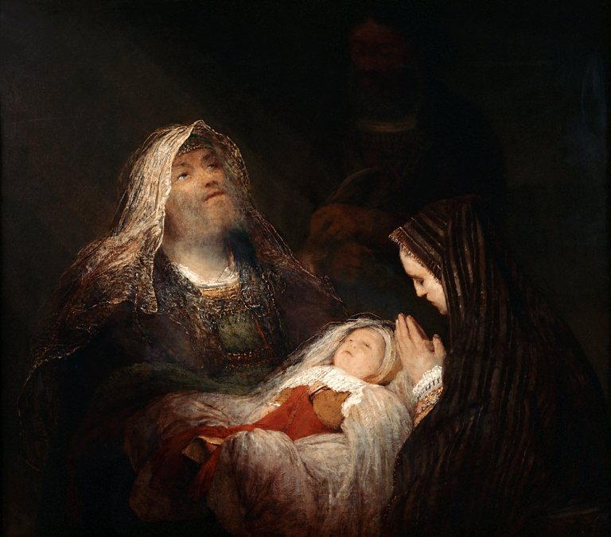
‘Like the shepherds and the wise men, Simeon and Anna are not strategic witnesses to the coming of the Messiah. Although both are clearly known in their community for their holiness and their spiritual discernment, their time is short, and not many will see the baby through their eyes.
De Gelder helps us to see why this does not matter. The child is his own illumination; light pours out from him. Yet God chooses that the first witnesses of his mighty act of salvation shall be the marginalised, the poor, the unorthodox and the old. This is the nature of God’s kingdom: it belongs to the poor, the meek, the merciful and those who, like Simeon and Anna, can see past the trappings of worldly kingship to the true God who has come to set his people free.
God does not choose the wealthy, the powerful or the successful to parent the Son, or to be his witnesses, because they would be in danger of misrepresenting the kingdom to fit their own success. Instead, God grows his kingdom gently, one person at a time, but with the inexorable power of resurrection life. From the testimony of the shepherds and magi, and later, the fishermen and tax collectors, outcast women and healed sinners, the good news that God is with us has spread over all the earth. Those of us who pass on the message now need to be careful that we understand the nature of this good news and do not make it in our own likeness. We need to test our hearts and our eyes: would we rejoice, like Simeon and Anna, at God, present in a helpless child, with no achievements to its name? Would we see the light that lightens the Gentiles, and rejoice? It is time to learn again from the witnesses that God invites to the birth of the Son.
Lord, present your Son, Jesus Christ, to us in the temples of our hearts and lives, and then send us out in the power of the Spirit to witness to your strange and glorious kingdom. Amen.’
From ‘The Art of Advent’ by Jane Williams, SPCK 2018

