COLLECT, READINGS AND REFLECTION
SUNDAY 21 JANUARY 2024- EPIPHANY 3

COLLECT
Almighty God,
whose Son revealed in signs and miracles
the wonder of your saving presence:
renew your people with your heavenly grace,
and in all our weakness
sustain us by your mighty power;
through Jesus Christ your Son our Lord,
who is alive and reigns with you,
in the unity of the Holy Spirit,
one God, now and for ever. Amen.

Psalm 128
1 Blessed are all those who fear the Lord, ♦
and walk in his ways.
2 You shall eat the fruit of the toil of your hands; ♦
it shall go well with you, and happy shall you be.
3 Your wife within your house
shall be like a fruitful vine; ♦
your children round your table,
like fresh olive branches.
4 Thus shall the one be blest ♦
who fears the Lord.
5 The Lord from out of Zion bless you, ♦
that you may see Jerusalem in prosperity
all the days of your life.
6 May you see your children’s children, ♦
and may there be peace upon Israel.

Genesis 14.17-20

Abram Blessed by Melchizedek
After his return from the defeat of Chedorlaomer and the kings who were with him, the king of Sodom went out to meet him at the Valley of Shaveh (that is, the King’s Valley). And King Melchizedek of Salem brought out bread and wine; he was priest of God Most High. He blessed him and said,
‘Blessed be Abram by God Most High,
maker of heaven and earth;
and blessed be God Most High,
who has delivered your enemies into your hand!’
And Abram gave him one-tenth of everything.

At Morning Prayer, the Gospel is simply the second reading, people sit to hear it and is introduced in the same way as the first:
The second reading is from John, chapter 2, verses 1-11.

and then at the end:
For the word of the Lord
Thanks be to God.

For a Eucharist/Communion from the Book of Common Prayer (Fitz), there is no Gospel Acclamation- people stand to hear the Gospel, and it is introduced with the words:
The Holy Gospel is written in the 2nd chapter of the Gospel according to St John, beginning at the first verse.
Glory be to thee, O Lord.

And then at the end:
Praise be to thee, O Christ.

For Eucharists/ Communion around the rest of Severn Loop, people stand to hear the Gospel and it is introduced with an Acclamation, as below:
Alleluia! Alleluia!
Christ was revealed in flesh, proclaimed among the nations and believed in throughout the world.
Alleluia!

Hear the Gospel of our Lord Jesus Christ, according to John, chapter 2 verses 1-11.
Glory to you, O Lord

And then at the end:
This is the Gospel of the Lord.
Praise to you, O Christ.

John 2.1-11

The Wedding at Cana
On the third day there was a wedding in Cana of Galilee, and the mother of Jesus was there. Jesus and his disciples had also been invited to the wedding. When the wine gave out, the mother of Jesus said to him, ‘They have no wine.’ And Jesus said to her, ‘Woman, what concern is that to you and to me? My hour has not yet come.’ His mother said to the servants, ‘Do whatever he tells you.’ Now standing there were six stone water-jars for the Jewish rites of purification, each holding twenty or thirty gallons. Jesus said to them, ‘Fill the jars with water.’ And they filled them up to the brim. He said to them, ‘Now draw some out, and take it to the chief steward.’ So they took it. When the steward tasted the water that had become wine, and did not know where it came from (though the servants who had drawn the water knew), the steward called the bridegroom and said to him, ‘Everyone serves the good wine first, and then the inferior wine after the guests have become drunk. But you have kept the good wine until now.’ Jesus did this, the first of his signs, in Cana of Galilee, and revealed his glory; and his disciples believed in him.

A Reflection from Hannah….

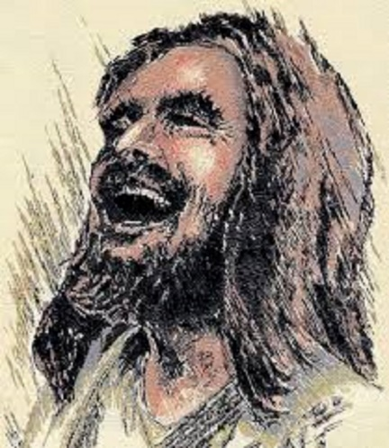

This image is called ‘Laughing Jesus’. What do you think? Of course our faith is a serious thing; it’s the home of our ultimate hope, gives meaning to the cosmos, sustains us in love… but perhaps we can sometimes be a bit serious about it… or, mid-way through January (which is apparently the most miserable month of the year) feel a bit devoid of lightness. This image of Jesus with head thrown back in a belly-laugh helps us in a similar way to the account of the wedding at Cana in our Gospel reading. In both cases we are reminded that joy, fun and delight are the stuff of Christ and an integral part of who we are. Great saints remind us of that too- like the late Archbishop Tutu, who had such a memorable and infectious giggle.

But sadly, the stereotype of a Christian today is more likely to describe someone dour, solemn and humourless. The context for Jesus’ first miracle- his first act that draws gasps of amazement and unsteadies everything- is a rather far-gone wedding party, where the simple fact that the wine has run out lets us know that it’s not a place of sobriety and dignity, but of raucous celebration, energy, joy and dancing. Jesus is in the thick of the good things that we celebrate.

The turning of water into wine is what John describes as the ‘first sign’ and it is about lavish hospitality, lightness and enjoyment- these are things of the Kingdom of God. So when we are tempted to take Jesus (and ourselves) a bit too seriously, noticing only the suffering servant, the challenging teacher, and forgetting the inevitable smiling and giggling and joking that would also have been part of showing us what the Kingdom of God is about, the message and the position of this miracle in the Gospel of John provides an important counterpoint.

The ‘first sign’ is a party, and it’s also a glimpse of the life of Heaven. A recurring image in scripture is of Heaven as a wedding feast. When I was a child, I distinctly remember dreading the heavenly life because one way it was described to me was as a church service that never ends. Can you imagine?! Based on my experiences of church at that point, it was a clear no thanks. But a banquet, a celebration, a place where the wine just keeps getting better and Jesus is our company; there is a picture that beckons us and brings us hope.

