Priest-in-Charge: The Revd Hannah Lins
07736 012011 revhannahlins@gmail.com
Assistant Priest: The Revd Peter Allan
www.severnloopparishes.org.uk 01939 290048 pallan412@gmail.com
Loop Safeguarding Officer: Mrs Philippa Herbert 01939 291352 Lay Pastoral Minister: Mrs Joyce Jagger
Sharing the Light in the Loop 01743 298285 weekly worship 07802 695954 pearhill1@outlook.com
Daily Hope – the national service 0800 804 8044
JUNE LOOP 2024
Weekly Collects, Readings and Reflection are on the website (see above.)

Summer is here!

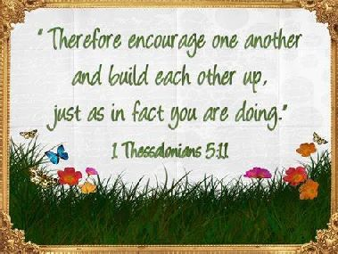
Buckle-up! There is plenty going on in Severn Loop this month- so our newsletter is largely full of information about upcoming events and services. It’s lovely to be able to make the most of the warmer weather and lighter days, and as we do it gives us an opportunity to thank God for the beauty of the earth and the delights of June. Do feel warmly invited to all that’s going on- over the past four years or so, we’ve been so encouraged by increasing numbers of people travelling to other churches in the Loop to support different events… it’s a real joy to see that, because we are stronger together- building up fellowship between congregations is a key part of expressing God’s love and bearing witness to the Holy Spirit at work in every place. And of course, please do invite friends and neighbours too!

Archdeacons’ Visitation

Every year our churchwardens get sworn-in at a special service for the whole of the Deanery. This year, Leaton is hosting it. Do come along and support our wonderful wardens, whose energy, commitment, practical know-how and prayerfulness is so deeply appreciated in all our churches. We would be snookered without them! The service is on Wednesday, 26th June, 7pm (arrival from 6pm, refreshments on arrival).
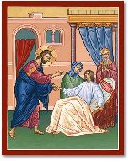
United Healing Service- 30th June

You may remember that back in 2017 we held a couple of healing services around Severn Loop? We are very pleased to say that we’ll be reviving this tradition. On 30th June our united service will be a healing service within the context of the Eucharist. It’s an opportunity to pray for healing and wholeness, for ourselves and for others. All are most welcome- Fitz Church, 10.30am.

Forest Church
We had a great time at Beam House, Little Ensdon! Our next Forest Church is:

Sunday, 7th July, 3pm
Pimhill Barn at Lea Hall, SY4 3DY

More information in next month’s Loop…

Teddy Bear Parachute Drop and Bake-Off
Saturday, 29th June 2024
11.30am-1pm, Bicton Church
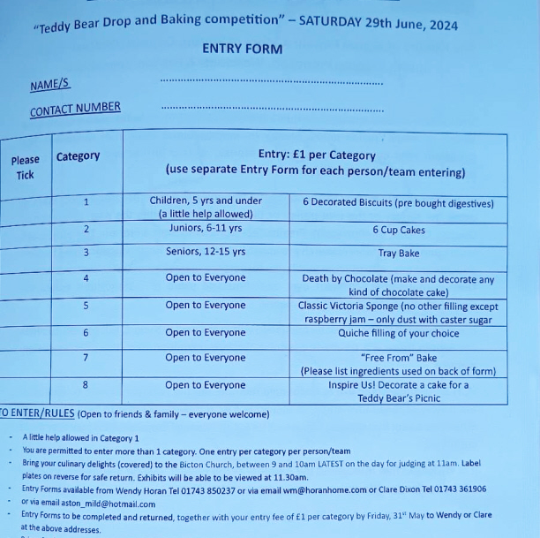
Make a parachute for your teddy and bring it along. It’ll be launched off the top of the tower and there will be a prize for the teddy who hits the target!

This year there will also be a Bake-Off to enter - here is the form - or contact Wendy Horan at wm@horanhome.com or 01743 850237.

Diary Dates
Bicton CAMEO Coffee Morning- 13th June, 10.30am- noon. In church.
Friends Coffee Morning, St Mary’s, Shrawardine- Tuesday, 25th June, 10.30am.
The Stepping Out Café in Bomere Heath- 26th June, 2.30pm-4pm, Mission Church.
Filling Station- Knockin Village Hall is on 18th June, 7.10pm for a 7.30pm start. The next one at Rodington Village Hall (SY4 4QS) is on 24th June 2024, 7.15pm for a 7.30pm start.
Bicton Church is now open on Saturday mornings- 10am-noon- for visitors and/ or private prayer.

*Please note that Fitz Village Fete, which had been scheduled for 8th June, has been cancelled.*

Sunday@6
Due to multiple technical issues, we’ve now moved across from Zoom to Google Meet. Our first week on this platform went really well! If you’d like to receive the link to Sunday@6, do contact Hannah. We meet online every week at 6pm to say Evening Prayer together.

For Your Prayers
- For candidates in the General Election and all who are canvassing.
- For the people of Israel and Palestine and the people of Ukraine- for peace.
- For all those preparing for Baptism or to be married.
- For those in hospital, and for our NHS.
- For our local schools.
- For all who mourn.

Royal British Legion Service
Royal British Legion Service with the Porthywaen Band
6pm, 9th June, Bicton Church
Before the service, the band will march from the village hall to the church. There will be refreshments at the club afterwards. Please note that there will be no morning service at Bicton that day.

Readings for June
Date | Psalm | First Reading | Second Reading/ Gospel
2nd June  Trinity 1, green | 81.1-10 | Deuteronomy 5.12-15 | Mark 2.23 - 3.6
9th June  Trinity 2, green | 130 | Genesis 3.8-15 | Mark 3.20-35
16th June  Trinity 3, green | 92.1-4, 12-15 | Ezekiel 17.22-24 | Mark 4.26-34
23rd June  Trinity 4, green | 107. 1-3, 23-32 | Job 38.1-11 | Mark 4.35-41
30th June  Trinity 5, green | 30 | Lamentations  3.23-33 | Mark 5.21-43
7th July  Trinity 6, green | 123 | Ezekiel 2.1-5 | Mark 6.1-13

SUNDAY SERVICES FOR JUNE 2024

 | Albrighton | Bicton | Bomere  Heath | Fitz | Leaton | Montford | Shrawardine
2nd June | 9.15 am  HC | 11am  HC |  | 9.30 am  HC | 10.45 am  HC |  | 9.30 am  MP
9th June |  | 6pm  British Legion Service | 9 am  HC |  | 10.45 am  MP | 9.30 am  HC | 11 am  HC
16th June | 9.15 am  MP | 11 am  HC |  | 9.30 am  HC | 10.45 am  HC | 9.30 am  MP
23rd June |  | 11 am  MP | 9 am  HC |  | 10.45 am  MP | 11 am  HC | 9.30 am  HC
30th June |  |  |  | Healing Service united service  10.30am
7th July | 9.15 am  HC | 11am  HC |  | 9.30 am  HC | 10.45 am  HC |  | 9.30 am  MP

HC- Holy Communion; MP- Morning Prayer

OTHER WAYS TO WORSHIP ON SUNDAYS
SUNDAY AT SIX 6 pm via Zoom – email Peter or Hannah to receive the link.
SHARING THE LIGHT IN THE LOOP- weekly phone line worship – see top of this page for the number.
DAILY HOPE – national phone line, see number above.
LICHFIELD CATHEDRAL- www.lichfield-cathedral.org 10.30 am Eucharist

