

**Priest-in-Charge:** The Revd Hannah Lins

07736 012011 [revhannahlins@gmail.com](mailto:revhannahlins@gmail.com)

**Assistant Priest:** The Revd Peter Allan

[www.severnloopparishes.org.uk](http://www.severnloopparishes.org.uk) 01939 290048 [pallan412@gmail.com](mailto:pallan412@gmail.com)

**Loop Safeguarding Officer:** Mrs Philippa Herbert 01939 291352 **Lay Pastoral Minister:** Mrs Joyce Jagger

**Sharing the Light in the Loop** 01743 298285 weekly worship 07802 695954 [pearhill1@outlook.com](mailto:pearhill1@outlook.com)

Daily Hope – the national service 0800 804 8044

**NOVEMBER LOOP 2024**

**Weekly Collects, Readings and Reflection are on the website (see above.)**

**A Season of Remembrance**

As conflict escalates around the world and we continue to pray for peace in our daily prayers, our season of remembrance is greeted with profound fervour this year. As always, we remember those whom we love but see no longer, we remember those who have served in past wars, and we remember those who are serving with the Armed Forces today. We are aware that within our congregations a number of folk have close family members in active service, so they are particularly in our hearts at this time.

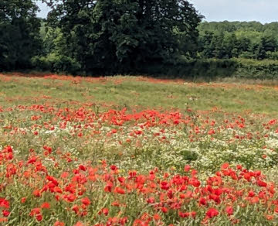

**Remembrance Sunday Services**

Bomere Heath 9am

Montford 9.30am

Shrawardine 10.45am

Bicton 10.45am

Leaton 10.45am, followed by acts of remembrance at the war memorial on the junction, and at Preston Gubbals church

Fitz 5.30pm- Festival of Remembrance with the Yeoman Singers

On Monday, 11th November there will be an outdoor act of remembrance at the Methodist Church in Bomere Heath, and at Battlefield Church. In both cases, gather from 10.50am.



**Forest Church**

Our next Forest Church will be on **1st December, 3pm at the Mission Church in Bomere Heath**. We are stretching the definition and going indoors for the darkest time of the year! We’ll be doing a variety of Christmas card crafts. All are welcome.

**Light for a Loved One**

As last year, Bicton Church is inviting members of the community to remember loved ones over the Christmas period on the notice board outside church, and on our Christmas Tree. If you would like to be part of this, the form to complete is at the end of the Loop.

**Looking ahead to Christmas**

There will be plenty of information in our next Loop, but here are a few key dates for your diary, along with some publicity about particular events.

**Carol Services around Severn Loop:**

Battlefield- 8th December, 2pm

Bicton- 12th December carol concert (see below)

Albrighton- 15th December, 9.15am

Montford- 15th December, 11am

Leaton- 15th December, 7pm

Preston Gubbals- 22nd December, 2pm

Fitz- 22nd December, 5pm

Shrawardine- 22nd December, 7pm

*Carol singing in the Red Lion pub in Bomere Heath will be on 10th December, 6pm.*

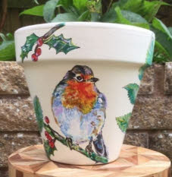

**Festive Pot Painting Evening**

Wednesday 20th November 7pm

Mission Church, Bomere Heath.

Cost £12 to include a pot to paint, materials to paint with and refreshments. We will be guided by an experienced artist, and no existing skills are needed!

*A great Christmas present for a friend or relative*

*Please give your name with money to Pat Hall, 01939 290637.*

**St. PETER & St. PAUL’S CHURCH**

**FITZ**

**COMMUNITY ADVENT LUNCH**

**With Festive Singalong**

**FITZ VILLAGE HALL**

**SUNDAY 1st DECEMBER**

**12:30pm**

**ADULTS £10—CHILDREN £5**

**Tickets available from Avril**

**On 01743 850262. avril.stephens10 @gmail.com**

**Please Bring Your Own Drink**

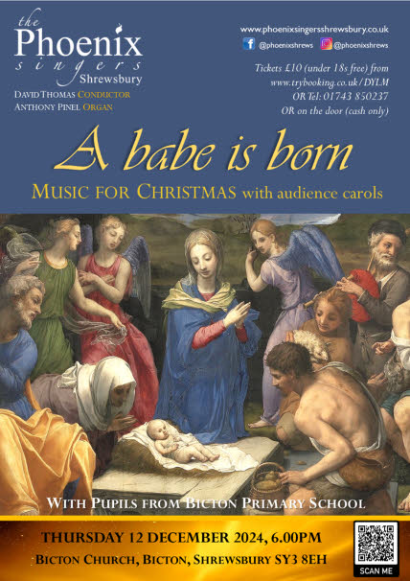

**Ministry Update**

This month, we are very grateful to Bishop Alistair Magowan, Revd. Paul Firmin, Revd. Kevin Roberts, Fr. Stan Swift and someone (we don’t yet know who!) from the team at Meole Brace who will be covering services for us.

**Diary Dates**

**CAMEO Coffee Morning at Bicton Church-** 14th November, 10.30am-11.30am.

**The Stepping Out Café in Bomere Heath-** 27th November, 2.30pm-4pm.

**Filling Station**- Knockin Village Hall is on 19th November, 7.10pm for a 7.30pm start. The next one at Rodington Village Hall (SY4 4QS) is on 25th November 2024, 7.15pm for a 7.30pm start.

**REVS-** 17th November, 9.30am-noon, Montford Bridge Café.

**Remembering with Love**

Our annual Remembering with Love service will be at 3pm on Sunday, 3rd November, at Leaton. At this service we read out the names of loved ones lost. If you would like a name remembered, please let Hannah know by 1st November at [revhannahlins@gmail.com](mailto:revhannahlins@gmail.com).

**For Your Prayers**

* For our local farmers.
* For peace in the Middle East.
* For Leaton churchyard- as the rain brings more groundwater flooding.
* For Kristen and Jake preparing to be married at Leaton.
* For those in hospital, and for our NHS.
* For the presidential campaign in the US.
* For those sleeping on the streets as the nights get cooler.

**Readings for November**

|  |  |  |  |
| --- | --- | --- | --- |
| **Date** | **Psalm** | **First Reading** | **Second Reading/ Gospel** |
| 3rd November  All Saints | 24.1-6 | Isaiah 25.6-9 | John 11.32-44 |
| 10th November  3 before Advent | 62.5-12 | Jonah 3.1-5,10 | Mark 1.14-20 |
| 17th November  2 before Advent | 16 | Daniel 12.1-3 | Mark 13.1-8 |
| 24th November  Christ the King | 93 | Daniel 7.9-10,13,14 | John 18.33-37 |
| 1st December  Advent Sunday | 25.1-9 | Jeremiah 33.14-16 | Luke 21.25-36 |

**SUNDAY SERVICES FOR NOVEMBER 2024**

|  |  |  |  |  |  |  |  |
| --- | --- | --- | --- | --- | --- | --- | --- |
|  | **Albrighton** | **Bicton** | **Bomere**  **Heath** | **Fitz** | **Leaton** | **Montford** | **Shrawardine** |
| **3rd November**  **White** | 9.15 am  HC | 11 am  HC |  | 9.30 am  HC | 10.45 am  HC  3pm  Remembering with Love |  | 9.30 am  MP |
| **10th November**  **Remembrance**  **Red** |  | 10.45 am  MP | 9 am  HC | 5.30pm  Festival of Remembrance | 10.45 am  MP | 9.30 am  HC | 10.45 am  HC |
| **17th November**  **Green** | 9.15 am  MP | 11 am  HC |  | 9.30 am  HC | 10.45 am  HC | 9.30 am  MP |  |
| **24th November**  **Red** |  | 11 am  MP | 9 am  HC |  | 10.45 am  MP | 11 am  HC | 9.30 am  HC |
| **1st December**  **Purple** | 9.15 am  HC | 11 am  HC | 3pm Forest Church | 9.30 am  HC  12pm Community lunch | 10.45 am  HC |  | 9.30 am  MP |

***HC- Holy Communion; MP- Morning Prayer***

**OTHER WAYS TO WORSHIP ON SUNDAYS-** SUNDAY AT SIX 6 pm via Zoom – email Peter or Hannah to receive the link.SHARING THE LIGHT IN THE LOOP- weekly phone line worship – see top of this page for the number.DAILY HOPE – national phone line, see number above.LICHFIELD CATHEDRAL- www.lichfield-cathedral.org 10.30 am Eucharist

**Bicton Light for a Loved One**

In a similar way to the Hospice *Tree Of Light*, we are running our own *Light for a Loved One* from December onwards. Over the Christmas period we will have a special Christmas Tree outside the church door, lit as a memorial to loved ones at this special time of year. We will place the names of those remembered on the notice board, and on tree decorations- made in natural wood with a name etched on (and available to keep afterwards). If you would like your loved one remembered in this way, then do please complete the form below, and return it to Mrs. Clare Dixon, Revd. Hannah Lins or bring it to the church. Alternatively, you can email the details to [revhannahlins@gmail.com](mailto:revhannahlins@gmail.com). The deadline is 15th November.

|  |  |
| --- | --- |
| ***Name:*** | ***Email:*** |
| ***Phone number:*** | ***A personal message-*** to be placed alongside their name in the noticeboard (no more than ten words please):  *Example messages:*  *‘Adam Jones- especially remembered on his birthday, 17th December.’*  *‘Adam Jones- particularly on frosty mornings, as he loved the festive weather.’* |
| ***Name of loved one to be remembered:*** |

***Donation (please tick):***

Enclosed- cash (state amount)

Enclosed- Cheque

Paid by BACS (Bicton Parochial Church Council, 309626, 80567068. Please use the reference ‘Light’ followed by your name)

*Our suggested donation is £10 per name, and it will go towards the upkeep of the church.*