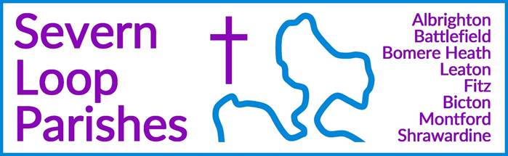

|  |  |  |
| --- | --- | --- |
| **Priest in Charge:** | Revd Hannah Lins | [revhannahlins@gmail.com](mailto:revhannahlins@gmail.com), 07736 012011 |
| **Assistant Priest:** | Revd Peter Allan | [pallan412@gmail.com](mailto:pallan412@gmail.com), 01939 290048 |
| **Pastoral Minister:** | Mrs Joyce Jagger | [pearhill1@outlook.com](mailto:pearhill1@outlook.com), 07802 695954 |
| **Safeguarding Officer:** | Mrs Philippa Herbert | 07871 865253 |
| **Administrator:** | Miss Rosie Dixon | [severn.loopparishes@gmail.com](mailto:severn.loopparishes@gmail.com) |
| **Daily Hope (the national phoneline service)** | | 0800 8048044 |
| *Weekly Collects, readings and reflections are on the website-* [*www.severnloopparishes.org.uk*](http://www.severnloopparishes.org.uk) | |  |

**MAY LOOP 2025**

**The Festival of Hope is underway!**

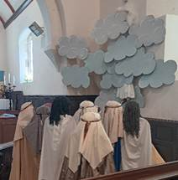

Our Festival of Hope began last Sunday and continues until 11th May. Please do download a pilgrim pass (or pick one up from one of our churches) and set off round the Loop to see our displays and reflections on stories of the risen Jesus- all open every day. Our community has worked really hard on this, and things all look amazing! Go to [www.severnloopparishes.org.uk](http://www.severnloopparishes.org.uk) to get all the information you need.

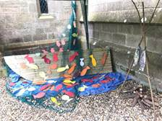

Our concert at Leaton is this coming Sunday, 3pm- *The Ronnies* will be entertaining us with music from the 1940s. It’s free, but do email [revhannahlins@gmail.com](mailto:revhannahlins@gmail.com) if you’re intending to come.

Then on **11th May, 5pm** we have our VE Day themed *Songs of Praise* at **Bicton**, with hymns chosen by people from around the Loop, and refreshments to follow- we’d love to see loads of you there!

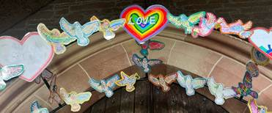

**The Lychgate at Battlefield- save the date**

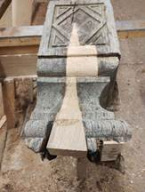

Work is underway to restore the lychgate- do take a look! It’s now thought that some of the timbers date to the early 17th century, so there is more to the story than was originally thought. We are going to have a Grand Opening on **20th July, 2pm**. Please do save the date. Anyone present who was baptised or married at Battlefield will be first to walk under the gate!

**Morning Prayer at Fitz**

The PCC at Fitz have decided that they’d like to try a service of Morning Prayer on the first Sunday of the month- that will be effective from May onwards. The third Sunday will still be a Eucharist.

**Remembering Nico**

Many of you will have heard by now the sad news that Mr Nicholas Stephens died on Holy Saturday. Nico was our Patron at Fitz, and served as Treasurer for many years. He will be deeply missed. A Thanksgiving Service to celebrate his life will be held at All Saints, Baschurch, 3pm on Thursday, 29th May. All are most welcome, but the family have asked that you let them know your intention to attend by emailing [rorrington.office@gmail.com](mailto:rorrington.office@gmail.com). Please keep Avril and the family in your prayers.

**Royal British Legion Service with the Porthywaen Band**

***6pm, 1st June, Bicton Church***

Before the service, the band will march from the village hall to the church. There will be refreshments at the club afterwards.

**Forest Church**

We had a lovely time walking from Shrawardine to Montford, to begin our Festival of Hope. Our next Forest Church will be on **13th July**, the venue will be confirmed nearer the time.

**Please check your spam!**

It’s a bit of a paradox to mention it, because if this email is in spam you’ve probably not seen it! Anyway, I’ve discovered that quite a few of my emails have been going straight to spam, and sometimes it seems to be linked to the content (particularly the subject)- so that means some emails from me may arrive, and others not. It’s a good idea to check your spam each week, just in case things have been wrongly filed! Thanks so much.

**Diary Dates**

**CAMEO Coffee Morning at Bicton Church-** 8th May, 10.30am-11.30am.

**The Stepping Out Café in Bomere Heath-** 28th May, 2.30pm-4pm

**Friends Coffee morning in Shrawardine-** 13th May, 10.30am in church

**Filling Station**- Knockin Village Hall is on 20th May, 7.10pm for a 7.30pm start. The next one at Rodington Village Hall (SY4 4QS) is on 26th May 2025, 7.15pm for a 7.30pm start.

**REVS-** Saturday, 17th May, 10am-noon, Holy Trinity, Leaton.

**For Your Prayers**

* For our Festival of Hope, including the concert and Songs of Praise.
* For peace.
* For the recently bereaved, especially the family and friends of Nicholas Stephens.
* For our local schools.
* For those in hospital, and for our NHS.
* For the repair works on the Battlefield lychgate.
* For Rebecca and Zak, getting married on 17th May.
* For Annie, being baptised on 25th May.

**Readings for May**

|  |  |  |  |
| --- | --- | --- | --- |
| **Date** | **Psalm** | **First Reading** | **Second Reading/ Gospel** |
| 4th May  Easter 3, white | Psalm 30 | Acts 9. 1-6 | John 21. 1-19 |
| 11th May  Easter 4, white | Psalm 23 | Acts 9. 36-43 | John 10. 22-30 |
| 18th May  Easter 5, white | Psalm 148 | Acts 11. 1-18 | John 13. 31-35 |
| 25th May  Easter 6, white | Psalm 67 | Acts 16. 9-15 | John 14. 23-29 |
| 1st June  Easter 7, white | Psalm 97 | Acts 16. 16-34 | John 17. 20-26 |

**SUNDAY SERVICES FOR MAY 2025**

|  |  |  |  |  |  |  |  |
| --- | --- | --- | --- | --- | --- | --- | --- |
|  | **Albrighton** | **Bicton** | **Bomere**  **Heath** | **Fitz** | **Leaton** | **Montford** | **Shrawardine** |
| **4th May** | 9.15 am  HC | 11 am  HC |  | 9.30 am  MP | 10.45 am  HC |  | 9.30 am  MP |
| **11th May** |  | 5pm  Songs of Praise | 9 am  HC |  | 10.45 am  MP | 9.30 am  HC | 11 am  HC |
| **18th May** | 9.15 am  MP | 11 am  HC |  | 9.30 am  HC | 10.45 am  HC | 9.30 am  MP |  |
| **25th May** |  | 11 am  MP | 9 am  HC |  | 10.45 am  MP | 11 am  HC | 9.30 am  HC |
| **1st June** | 9.15am  HC | 6pm  RBL Service |  | 9.30am  HC | 10.45am  HC |  | 9.30am  MP |

*Please note there will be NO Ascension Day service this year.*

***HC- Holy Communion; MP- Morning Prayer***

**OTHER WAYS TO WORSHIP ON SUNDAYS-** SUNDAY AT SIX 6 pm via Zoom – email Peter or Hannah to receive the link.DAILY HOPE – national phone line, see number above.LICHFIELD CATHEDRAL- www.lichfield-cathedral.org 10.30 am Eucharist

