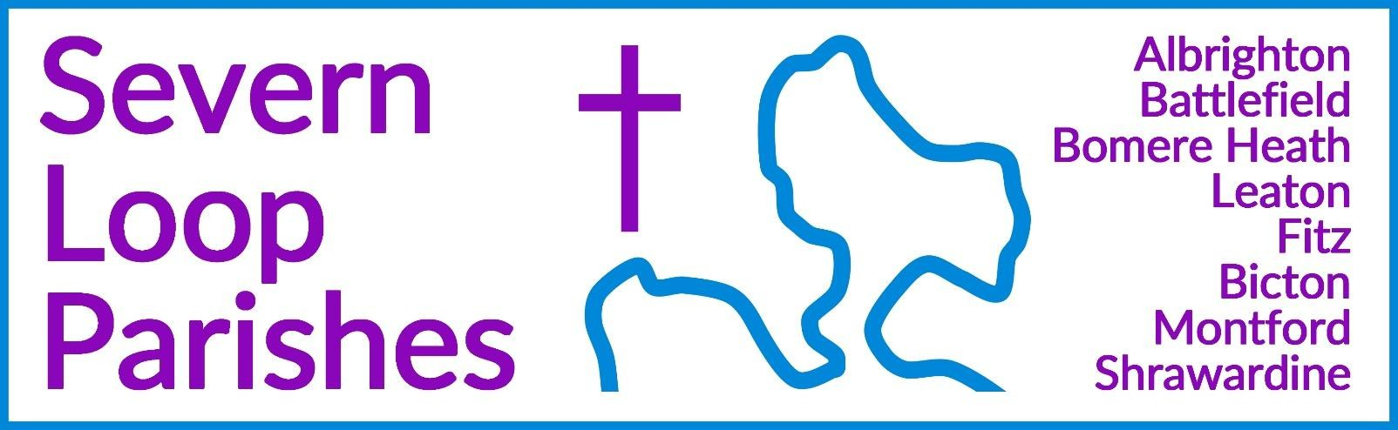

**Priest in Charge:** Revd Hannah Lins [revhannahlins@gmail.com](mailto:revhannahlins@gmail.com), 07736 012011

**Assistant Priest: Curate:**

Revd Peter Allan Revd David Latcham

[pallan412@gmail.com](mailto:pallan412@gmail.com), 01939 290048

[rev.latcham@gmail.com](mailto:rev.latcham@gmail.com), 07745 968298

**Pastoral Minister:** Mrs Joyce Jagger [pearhill1@outlook.com](mailto:pearhill1@outlook.com), 07802 695954

**Safeguarding Officer:** Mrs Philippa Herbert 07871 865253

**Administrator:** Miss Rosie Dixon [severn.loopparishes@gmail.com](mailto:severn.loopparishes@gmail.com)

**Daily Hope (the national phoneline service)** 0800 8048044

*Weekly Collects, readings and reflections are on the website-* [*www.severnloopparishes.org.uk*](http://www.severnloopparishes.org.uk/)

SEPTEMBER LOOP 2025

## Confirmation

We are looking forward to welcoming Bishop Michael on Sunday (7th September) for our Confirmation Service- 5pm, Leaton. We have five candidates- please do keep them in your prayers this coming week. It is always a delightful privilege to welcome people into the fellowship of faith through Confirmation and to mark this moment in our pilgrimage together. What a joy to see our church family growing!

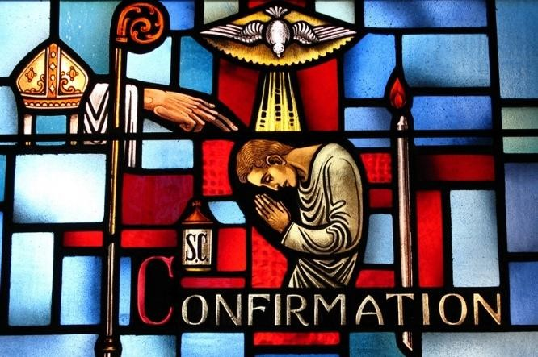For many of the candidates, it’ll also mark their first communion. As I’m sure you know, in the Church of England there are various approaches to the relationship between baptism, confirmation and communion. You may well have noticed that in recent weeks as Dave and his family have become part of our church family. Many years ago, some churches (including Meole Brace) opted into the CofE provision for admitting children to communion- so his children receive it, as have mine from a very young age (Heni was

two years old I think). It’s good to affirm and embrace the breadth of theology amongst us, but also to rejoice that whatever our age or stage, the Eucharist is a place of Spirit-filled encounter, a visible sign of God’s invisible grace. Next week’s confirmation service will be very special! Please come along to support those being confirmed.

Please note there will be **NO morning service at Leaton on 7th September and no Sunday@6.**

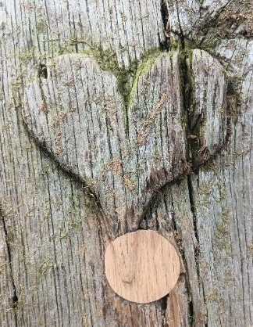

**Forest Church**

Our next Forest Church will be on 21st September at Battlefield Church SY3 3DB at 3pm. Join us to explore the nature in the churchyard, featuring bulb and possibly herb planting, ending with a short service. There is limited parking at the church, and plenty at 1403. Bring your own picnic (drinks provided). For those of you who haven’t been before, it’ll also be a chance to see the new lychgate, path and noticeboards- all very shiny and lovely!

All welcome.

## A person standing in a tent with chairs AI-generated content may be incorrect.Steam Rally Service

A new venture for us! This year, Dave was invited to take the Sunday evening service at the Steam Rally. He had thirty people, two dogs, and four steam engines flanking the tent and peering in! Thanks too to David Fletcher who played the keyboard. We were delighted to be part of this hugely popular event in our parish.

**A new home group**

We continue to be very grateful to Chris and Robin Oake, who run Seekers- a home group in Bicton, on Monday evenings. We are looking to start another home group, running on a Wednesday evening (final venue tbc). Home groups are small fellowship groups in which people study the Bible together, encourage each other and pray for one another. If you are interested of being part of a new, Wednesday night group, please do come to our initial meeting at **The Mission Church in Bomere Heath, on Wednesday, 10th September, 7.30pm.**

## Pet Blessing and Pet Therapy Ministry at Union Church – Westside News IncPet Service at Bicton

We are having a Pet Service at Bicton on 14th September, 11am. Please do come along with your pet as we give thanks for our non-human friends and recognise that they too are held in God’s love. All manner of animals welcome!

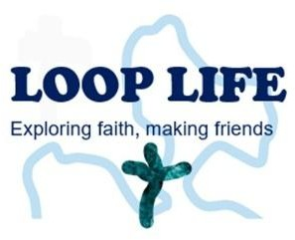

**Loop Life Youth Group**

… is back this term- on the second and fourth Thursdays of the month, in term time, 7pm-8pm, at the Rectory in Bicton. If you know of anyone in secondary school up to age 18 who would like to come along, please let Hannah know. We’re also looking to start a group for primary school aged children very soon- specific details in the October Loop.

## Harvest Meals

There will be more information in next month’s Loop about services, but this year we have two

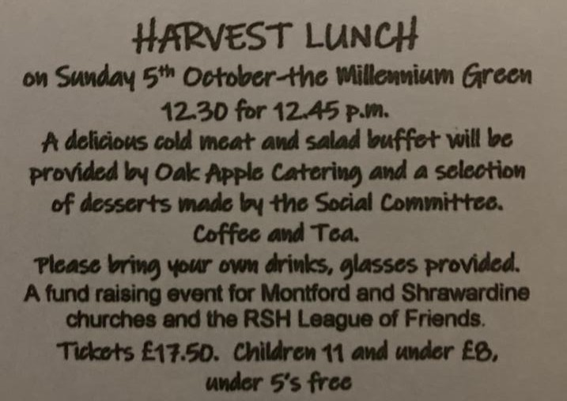Harvest meals- details below:

# A Harvest Festival Celebration Ecumenical Supper

Bring and Share finger buffet

Monday 6th October, The Mission Church, Bomere Heath

7pm for a 7.30pm start

Book with Pat Hall- 01939 290637 (limited numbers)

**Diary Dates**

**CAMEO Coffee Morning at Bicton Church-** 11th September, 10.30am-11.30am.

**The Stepping Out Café in Bomere Heath-** 24th September, 2.30pm-4pm

**Filling Station**- Knockin Village Hall is on 16th September, 7.10pm for a 7.30pm start. The next one at Rodington Village Hall (SY4 4QS) is on 22nd September 2025, 7.15pm for a 7.30pm start. **REVS-** Saturday, 20th September, 10am-noon, Holy Trinity, Leaton.

## For Your Prayers

* For our local farmers.
* For peace.
* For the recently bereaved.
* For Forest Church and our ministry to children.
* For our confirmation candidates and those being baptised.
* For Catrin and Andrew, getting married at Fitz this month.

**Readings for September**

|  |  |  |  |
| --- | --- | --- | --- |
| **Date** | **Psalm** | **First Reading** | **Second Reading/ Gospel** |
| 7th September Trinity 12, green | Psalm 1 | Philemon 1-12 | Luke 14. 25-33 |
| 14th September  Trinity 13, green | Psalm 51. 1-11 | 1 Timothy 2. 12-17 | Luke 15. 1-10 |
| 21st September  Trinity 14, green | Psalm 113 | 1 Timothy 2. 1-7 | Luke 16. 1-13 |
| 28th September  Trinity 15, green | Psalm 146 | 1 Timothy 6. 6-19 | Luke 16. 19-31 |
| 5th October  Trinity 16, green | Psalm 37. 1-9 | 2 Timothy 1. 1-14 | Luke 17. 5-10 |

# SUNDAY SERVICES FOR SEPTEMBER 2025

|  |  |  |  |  |  |  |  |
| --- | --- | --- | --- | --- | --- | --- | --- |
|  | **Albrighton** | **Bicton** | **Bomere**  **Heath** | **Fitz** | **Leaton** | **Montford** | **Shrawardine** |
| **7th September** | 9.15am HC | 11am HC |  | 9.30am MP | 5pm Confirmation |  | 9.30am MP |
| **14th**  **September** |  | 11 am  MP -  Pet  Service | 9 am  HC |  | 10.45 am  MP | 9.30 am  MP | 11 am  MP |
| **21st September** | 9.15 am MP  3pm Forest Church Battlefield | 11 am MP |  | 9.30 am HC | 10.45 am HC | 9.30 am MP |  |
| **28th September** |  | 11 am MP | 9 am HC |  | 10.45 am MP | 11 am HC | 9.30 am HC |
| **5th October** | 9.15am HC | 11am Harvest  Festival |  | 9.30am Harvest  Festival | 10.45am  Harvest  Communion | No service | No service |

***HC- Holy Communion; MP- Morning Prayer***

**OTHER WAYS TO WORSHIP ON SUNDAYS-** SUNDAY AT SIX 6 pm via Zoom – email Peter or Hannah to receive the link. DAILY HOPE – national phone line, see number above. LICHFIELD CATHEDRAL- [www.lichfield-cathedral.org](http://www.lichfield-cathedral.org/) 10.30 am Eucharist

