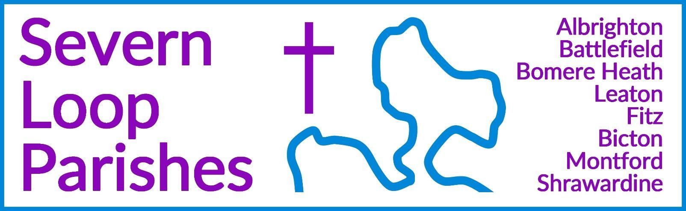
Priest in Charge: Revd Hannah Lins revhannahlins@gmail.com, 07736 012011

Assistant Priest: Curate:
Revd Peter Allan Revd David Latcham
pallan412@gmail.com, 01939 290048
rev.latcham@gmail.com, 07745 968298

Pastoral Minister: Mrs Joyce Jagger pearhill1@outlook.com, 07802 695954
Safeguarding Officer: Mrs Philippa Herbert 07871 865253
Administrator: Miss Rosie Dixon severn.loopparishes@gmail.com
Daily Hope (the national phoneline service) 0800 8048044

Weekly Collects, readings and reflections are on the website- www.severnloopparishes.org.uk

FEBRUARY LOOP 2026

Lent
At the risk of ‘banging on’ (as my children would put it!), can I once again share with you my favourite seasonal preface:

‘For in these forty days
you lead us into the desert of repentance that through a pilgrimage of prayer and discipline
we may grow in grace
and learn to be your people once again. Through fasting, prayer and acts of service you bring us back to your generous heart.
Through study of your holy word
you open our eyes to your presence in the world and free our hands to welcome others
into the radiant splendour of your love.’

The rhythm of fasting and feasting, so fundamental to the liturgical year, really matters. Especially in a society that loves the feast to just keep on going! This prayer, said before communion Sunday by Sunday during Lent, reminds us of the importance of the desert to our own formation and understanding of ourselves as God’s people. May you enter into it wholeheartedly, and through doing so, may you (as the prayer says) have your eyes opened to the presence of God in the joys and the agonies of this world.

We begin Lent together on Ash Wednesday (18th Feb), with a service at Bicton at 11.30am, followed by a soup lunch. Please do feel most welcome, and please let Wendy (01743 850237) know if you are staying for lunch- we would LOVE you to, but knowing numbers helps us not to waste food or have too little.

Encountering Jesus through ‘The Chosen’
If you haven’t already seen it, “The Chosen” is a highly successful, multi-season, historical drama based on the life of Jesus Christ, seen through the eyes of those who knew him. Its worldwide appeal has amassed 280 million viewers online, appealing to both those with and without Christian faith.
At its heart, it tells the story of Jesus, bringing the words of the Bible to life by providing a dramatic context for those words within Jesus’ revolutionary life and teachings.
Across five Tuesday mornings during lent, we are going to explore something of the controversy Jesus would have stirred in his own time, and the increasing hostility he faced, that led to the events of Easter, and his death on the cross. Each Tuesday we will begin with a short service of Holy Communion, and then (with a cup of coffee in our hands) we will watch a section of “The
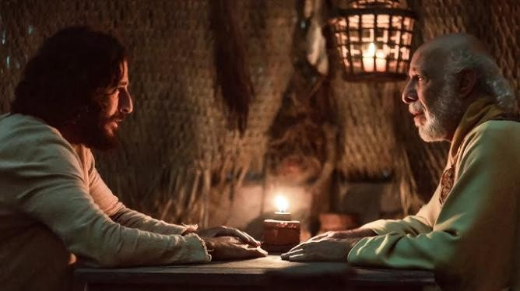
Chosen” and discuss its message. We will be joined by our Methodist friends, and all are welcome!
10.45am-noon, The Mission Church in Bomere Heath, Tuesdays 24th February, 3rd, 10th, 17th and 24th March.
Revd. David Latcham


Forest Church
Our next Forest Church will be in the woodland area at Bicton School, 3pm on 22nd February. We are hoping to have a campfire! Do join us for time exploring nature, followed by a short worship service and refreshments. This will be the first Forest Church of 2026, and so it would be lovely to get it off to a strong start!

Loopy Sundays

Our new, informal Sunday afternoon worship is continuing into February! We are meeting at 3pm on the 8th February at the Mission Church in Bomere Heath. Do join us for an afternoon of interactive Bible stories and activities, singing and snacking, suitable for all ages. This month, we will be exploring the idea of lent (which begins later in Feb) and forgiveness through Jesus' parable of the lost son. Feel free to just turn up, but if you’d like to find out more in advance, do email Dave
- rev.latcham@gmail.com.
Wednesday eve Small Group in Lent - reading Mark's gospel
During Lent, the Wednesday night Small Group will be reading through the whole of Mark's gospel in 3 parts, as a powerful way to see how Jesus' whole life and ministry lead towards Easter.
Join us on March 4th and 18th, and April 1st (in Holy Week) at 7:30pm in the Mission Church, Bomere Heath. For more details contact Dave - rev.latcham@gmail.com.


Maybe a gift for Mothering Sunday, a Birthday present or a gift for yourself.

Friday 6th March 7.30pm
Mission Church, Bomere Heath.
Cost £12 to include a pot to paint and materials to paint with.
Please speak to Pat Hall, 01939 290637.
Tuesday 17th February


Mission Church, Bomere Heath - 7 for 7.30pm Tickets £5 from 01939 290637 or church.

Bicton Church Coffee Morning and Ash Wednesday Service
Coffee morning Thursday 12th at 10.30am in Church
Ash Wednesday Service - Wednesday 18th followed by soup lunch. We need to know numbers for soup – please contact Wendy/Clare 01743 850237/01743 361906
An invitation from our friends at the United Reformed Church The Church Eco Group are hosting a community event in St Nicholas Hall Saturday 14th February 2026 10.30am – 1.30pm
A film showing of “Six Inches of Soil”
The inspiring story of young British farmers standing up against the industrial food system and transforming the way they produce food
Tickets available here, £3.70 https://kinema.com/events/Six-Inches-of-Soil-mu3ppz/tickets With refreshments and a Soup Lunch available provided by the Shrewsbury Food Hub


Coffee Mornings at Shrawardine
Come and join us for a friendly chat, coffee and cake!
Shrawardine Church, 10th February, 10.30am
for more information contact Jane or Mandy (07730 402037)
Diary Dates
CAMEO Coffee Morning at Bicton Church- 12th February, 10.30am-11.30am.
The Stepping Out Café in Bomere Heath- 25th February, 2.30pm-4pm
Filling Station- 17th February, 7pm for 7.30pm, ONLINE- February's meeting of North Shropshire & Borders Filling Station (usually in Knockin) will be at 7.30pm on Zoom only, on February 17th. The speaker will be Dave O Brien, author of Northern Soul and who used to be vicar at Oxon. If you'd like the Zoom link, please email brianjturner@btinternet.com
REVS- 21st February, 10am-noon, Leaton Church

For Your Prayers

- For peace in Sudan, the Middle East and Ukraine.
- For our local schools as term begins again.
- For our new lunch club at Corbet School, exploring the questions of faith.
- For those in hospital, and for our NHS.
- For those sleeping on the streets.
- For the recently bereaved

Readings for February

DAY | PSALM | 1ST READING | 2nd READING/  GOSPEL
1st February  Candlemas | Psalm 24. [1-6] 7-10 | Hebrews 2. 14-18 | Luke 2. 22-40
8th February  Second Sunday before Lent | Psalm 136. 1-9, 23-26 | Romans 8. 18-25 | Matthew 6. 25-34
15th February  Sunday before Lent | Psalm 99 | 2 Peter 1. 16-21 | Matthew 17. 1-9
22nd February  First Sunday of Lent | Psalm 32 | Romans 5. 12-19 | Matthew 4. 1-11
1st March  Second Sunday of Lent | Psalm 121 | Romans 4. 1-5, 12-17 | John 3. 1-17

SUNDAY SERVICES FOR FEBRUARY
 | Albrighton | Bicton | Bomere Heath | Fitz | Leaton | Montford | Shrawardine
1st February Candlemas |  |  |  |  |  |  | 10.30am  United  Service
8th February 2 before Lent |  | 11 am MP | 9am HC |  | 10.45 am MP | 9.30 am HC | 11 am HC
15th February Sunday before  Lent | 9.15 am MP | 11 am HC |  | 9.30 am HC | 10.45 am HC | 9.30 am MP
18th February Ash  Wednesday |  | 11.30am  Service with  ashing
22nd February First Sunday of Lent |  | 11 am MP  3pm Forest Church at the school | 9 am HC |  | 10.45 am MP | 11 am HC | 9.30 am HC
1st March Second Sunday of Lent | 9.15am HC | 11am HC |  | 9.30am HC | 10.45am HC |  | 9.30am MP
HC- Holy Communion; MP- Morning Prayer
OTHER WAYS TO WORSHIP ON SUNDAYS- SUNDAY AT SIX 6 pm via Zoom – email Peter or Hannah to receive the link. SHARING THE LIGHT IN THE LOOP- weekly phone line worship – see top of this page for the number. DAILY HOPE – national phone line, see number above. LICHFIELD CATHEDRAL- www.lichfield-cathedral.org 10.30 am Eucharist

