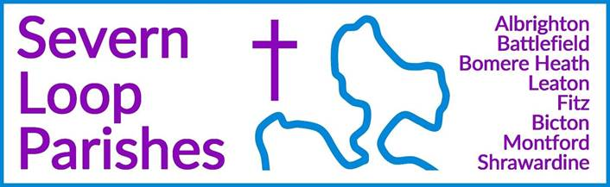
Priest in Charge: | Revd Hannah Lins | revhannahlins@gmail.com, 07736 012011
Assistant Priest:  Curate: | Revd Peter Allan  Revd David Latcham | pallan412@gmail.com, 01939 290048  rev.latcham@gmail.com, 07745 968298
Pastoral Minister: | Mrs Joyce Jagger | pearhill1@outlook.com, 07802 695954
Safeguarding Officer: | Mrs Philippa Herbert | 07871 865253
Administrator: | Miss Rosie Dixon | severn.loopparishes@gmail.com
Daily Hope (the national phoneline service) |  | 0800 8048044
Weekly Collects, readings and reflections are on the website- www.severnloopparishes.org.uk |  | 
APRIL LOOP 2026
Happy Easter (when it comes), and prayers for our new Archbishop

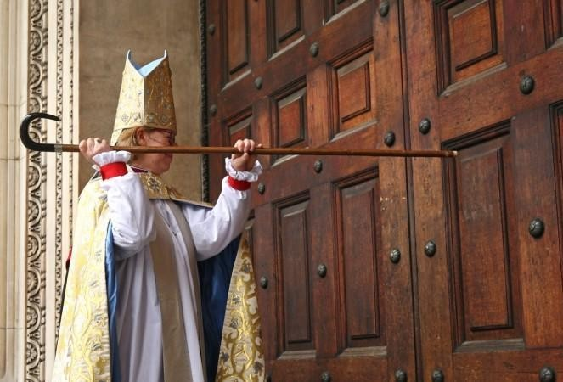
Last Wednesday (Lady Day- the Feast of the Annunciation) saw the installation of our new Archbishop of Canterbury- the Right Reverend and Right Honorable Dame Sarah Mullally. I sat down to watch it on iPlayer on Tuesday evening and it was wonderful! It’s still available, and I would heartily recommend it. There is, woven into the service, so much to celebrate and be thankful for. As is the case for the Church of England, our belief lives in our liturgy- there is a beautiful bit at the very beginning where the new Archbishop knocks on the door of Canterbury Cathedral, and is answered by children who ask for her name and her business. Her response is this:

‘I am Sarah, a servant of Jesus Christ, and I come as one seeking the grace of God, to travel with you in his service together.’

Rightly humble and straightforward, we are reminded that though we may have different roles and different gifts, we are all journeying as pilgrims together on this great adventure. As Easter Day lurks just over the horizon, we greet God’s ever-creating, ever-unfolding love, and we give thanks that as a new Archbishop begins her ministry, a new season of life together begins, and we are all made ready to embrace that resurrection joy in our lives today, whatever our circumstances.

Loopy Sundays
We are meeting at 3pm on the 12th April at the Mission Church in Bomere Heath. Do join us for an afternoon of interactive Bible stories and activities, singing and snacking, suitable for all ages. This month, we will be exploring one of the Easter stories - The Road to Emmaus. Feel free to just turn up, but if you’d like to find out more in advance, do email Dave - rev.latcham@gmail.com.

Wednesday eve Small Group in Lent - reading Mark's gospel
During Lent, the Wednesday night Small Group will be reading through the whole of Mark's gospel in 3 parts, as a powerful way to see how Jesus' whole life and ministry lead towards Easter.
Join us on April 1st (in Holy Week) at 7:30pm in the Mission Church, Bomere Heath. For more details contact Dave - rev.latcham@gmail.com.


Steeleye Span Concert
Charles Bridgeman (Leaton) is promoting this concert as a means of raising money for a family window- if you're interested in getting a ticket, please contact him directly- Cbridgeman@leatonforest.co.uk.



Fitz Village Hall Quiz night and Afternoon cream tea!
Friday 17th April
Monday 6th April

Of One Accord Concert – Bicton Church, 5th June at 7.30pm
A wonderful evening of uplifting music with Of One Accord, a mixed voice choir nestled in Shrewsbury. Tickets: £10 Including refreshments
To book your tickets, please contact Wendy/Clare – 01743 850237/01743 361906 or e-mail severn.loopparishes@gmail.com


Coffee Mornings at Shrawardine
Come and join us for a friendly chat, coffee and cake!
Venue will be either Shrawardine Church,
or there will be a notice on the gate directing you to a nearby house. 14th April.
for more information contact Jane or Mandy (07730 402037)

Forest Church
Our next Forest Church will be 26th April, 3pm at Preston Montford Field Studies Centre. We'll be doing pond dipping and learning about weather and the water cycle!

Dave’s Priesting Service
You’re warmly invited to join us on Sunday 21st June at 10:30am at Bicton Church, followed by a bring-and-share lunch.


COACH TRIP to Coventry Cathedral
Thursday 16th July including a special group tour, afternoon tea and choral evensong.
Save the date, more information coming very soon!

Diary Dates
NO CAMEO Coffee Morning at Bicton Church- 9th April due to a wedding being held that morning
The Stepping Out Café in Bomere Heath- 29th April, 2.30pm-4pm
Filling Station- 21st April, 7.15pm for 7.30pm, Knockin Assembly Rooms.
REVS- 18th April, 10am-noon, Leaton Church

For Your Prayers
- For peace in Sudan, the Middle East and Ukraine.
- For our local schools as they rnjoy the Easter holidays, and for all doing exams next term.
- For our new lunch club at Corbet School, exploring the questions of faith.
- For those in hospital, and for our NHS.
- For Adam and Claire, getting married at Bicton this month.
- For the recently bereaved- particularly the family and friends of Liz Payne.

Readings for April
DAY | PSALM | 1ST READING | 2nd READING/ GOSPEL
2nd April  Maundy Thursday | Psalm 116. 1, 10-17 | 1 Corinthians 11.  23-26 | John 13.  1-17, 31b-35
3rd April  Good Friday | Psalm 22 | Romans 5. 1-11 | John 4. 5-42
5th April  Easter Day | Psalm 118. 1-2, 14-24 | Colossians 3. 1-4 | Matthew 28. 1-10
12th April  2nd Sunday of Easter | Psalm 16 | 1 Peter 1. 3-9 | John 20. 19-31
19th April  3rd Sunday of Easter | Psalm 116. 1-3, 10-17 | 1 Peter 1. 17-23 | Luke 24. 13-35
26th April  4th Sunday of Easter | Psalm 23 | 1 Peter 2. 19-25 | John 10. 1-10
3rd May  5th Sunday of Easter | Psalm 31. 1-5, 15-16 | 1 Peter 2. 2-10 | John 14. 1-14

SUNDAY SERVICES FOR APRIL

 | Albrighton | Bicton | Bomere  Heath | Fitz | Leaton | Montford | Shrawardine
2nd April  Maundy Thursday |  | 7 pm  Eucharist | 7 pm  Agape
3rd April  Good Friday |  | 2 pm  Last hour | 2 pm  Last hour
5th April  Easter Day | Battlefield 5.30 am  9.15 am  HC | 11.15 am  HC | 8 am  HC | 10.15 am  HC | 10.45 am  HC | 9 am  HC | 8 am  HC
12th April  Easter 2 |  | 11 am  MP | 9 am  HC |  | 10.45 am  MP | 9.30 am  HC | 11 am  HC
19th April  Easter 3 | 9.15 am  MP | 11 am  HC |  | 9.30 am  HC | 10.45 am  HC | 9.30 am  MP
26th April  Easter 4 |  | 11 am  MP | 9 am  HC |  | 10.45 am  MP | 11 am  HC  Forest Church 3pm | 9.30 am  HC
3rd May  Easter 5  White | 9.15 am  HC | 11 am  HC |  | 9.30 am  MP | 10.45 am  HC |  | 9.30 am  MP

HC- Holy Communion; MP- Morning Prayer

OTHER WAYS TO WORSHIP ON SUNDAYS- SUNDAY AT SIX 6 pm via Zoom – email Peter or Hannah to receive the link. SHARING THE LIGHT IN THE LOOP- weekly phone line worship – see top of this page for the number. DAILY HOPE – national phone line, see number above. LICHFIELD CATHEDRAL- www.lichfield-cathedral.org 10.30 am Eucharist

