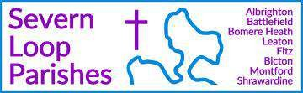

COLLECT, READINGS AND REFLECTION
SUNDAY 31 MAY 2026 – Trinity Sunday

COLLECT
Almighty and everlasting God, you have given us your servants grace,
by the confession of a true faith,
to acknowledge the glory of the eternal Trinity
and in the power of the divine majesty to worship the Unity: keep us steadfast in this faith,
that we may evermore be defended from all adversities; through Jesus Christ your Son our Lord,
who is alive and reigns with you, in the unity of the Holy Spirit, one God, now and for ever.

Psalm 8
- O Lord our governor, ♦
how glorious is your name in all the world!
- Your majesty above the heavens is praised ♦
out of the mouths of babes at the breast.
- You have founded a stronghold against your foes, ♦
that you might still the enemy and the avenger.
- When I consider your heavens, the work of your fingers, ♦
the moon and the stars that you have ordained,
- What is man, that you should be mindful of him; ♦
the son of man, that you should seek him out?
- You have made him little lower than the angels ♦
and crown him with glory and honour.
- You have given him dominion over the works of your hands ♦
and put all things under his feet,
- All sheep and oxen, ♦
even the wild beasts of the field,
- The birds of the air, the fish of the sea ♦
and whatsoever moves in the paths of the sea.
- O Lord our governor, ♦
how glorious is your name in all the world!

A reading from the second letter of Paul to the Corinthians, chapter 13, verses 11-13.

Finally, brothers and sisters, farewell. Put things in order, listen to my appeal, agree with one another, live in peace; and the God of love and peace will be with
you. Greet one another with a holy kiss. All the saints greet you.
The grace of the Lord Jesus Christ, the love of God, and the communion of the Holy Spirit be with all of you.

This is the word of the Lord. Thanks be to God.

For Eucharists/ Communion people stand to hear the Gospel. Everywhere except Fitz introduces it with an Acclamation (the blue bit), and then we all use the introduction and ending (the green bit):

Alleluia. Alleluia.
Blessed be God, Father, Son and Holy Spirit now and to the ages of ages!
Alleluia.

Hear the Gospel of our Lord Jesus Christ, according to Matthew, Chapter 28, verses 16-20.
Glory to you, O Lord

And then at the end:
This is the Gospel of the Lord.
Praise to you, O Christ.

Now the eleven disciples went to Galilee, to the mountain to which Jesus had directed them. When they saw him, they worshipped him; but some doubted. And Jesus came and said to them, ‘All authority in heaven and on earth has been given to me. Go therefore and make disciples of all nations, baptizing them in the name of the Father and of the Son and of the Holy Spirit, and teaching them to obey everything that I have commanded you. And remember, I am with you always, to the end of the age.’
This is the Gospel of the Lord Praise to you, O Christ

A Reflection from Peter

Here you can see a rare survival of English medieval Christian art: it is part of an altarpiece in painted and gilded alabaster (now in the Victoria & Albert Museum). This is the centre panel, depicting the crucifixion. But the cross here is not starkly isolated on a bare hill: the cross hangs between the knees of the much larger God the Father – with flowing beard, flowing robes, hands raised in blessing and with attendant angels blowing trumpets. It is, in fact, a representation of the Holy Trinity – but the Holy Spirit is missing (perhaps not totally inappropriately for someone who is, by nature, invisible)!
19th century German art historians called this kind of Trinitarian picture the ‘Gnadenstuhl’ (Throne of mercy) because the image recalls Hebrews 4.16 “let us therefore approach the throne of grace with boldness, so that we may receive grace to help in time of need.”

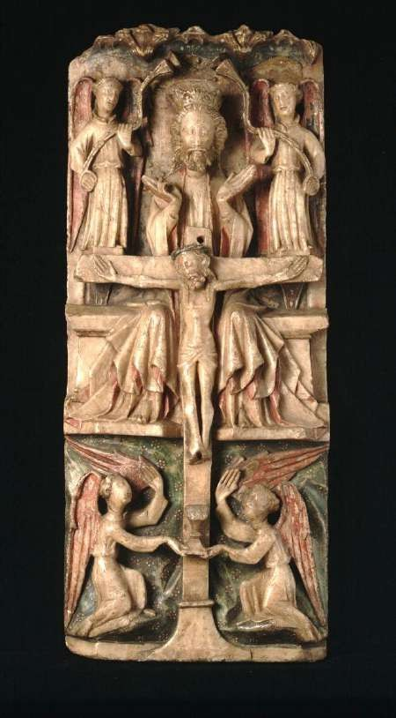
In medieval England it was a common way of imagining the Trinity – and the Holy Spirit was usually to be found in the form of a dove between
the Father and the Son, or hovering above the Fat. But just as we can recognise how this corresponds with some of the things we have been told about the Trinity, perhaps you can also see why one of the brothers at Mirfield disliked it intensely and railed against it as
heresy! It couldn’t be more different than the other famous representation of the Trinity in art, the Rublev icon – showing three figures seated around an altar. Here the three figures are the same size, dressed almost identically: it is their common, shared identity that is emphasised. In the English medieval version it is the difference between Father, Son and Spirit that is emphasised.
The truth is that God is all this and more – and not at different moments, but all at the same time. Trinity Sunday is not a day for trying to get our heads around impossible mathematical equations, but for praise and wonder that our God is infinitely greater than we can think or imagine.

