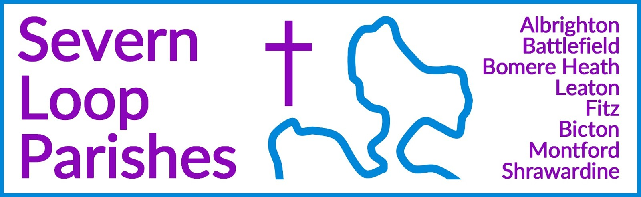
Priest in Charge: | Revd Hannah Lins | revhannahlins@gmail.com, 07736 012011
Assistant Priest:  Curate: | Revd Peter Allan  Revd David Latcham | pallan412@gmail.com, 07910 071489  rev.latcham@gmail.com, 07745 968298
Pastoral Minister: | Mrs Joyce Jagger | pearhill1@outlook.com, 07802 695954
Safeguarding Officer: | Mrs Philippa Herbert | 07871 865253
Administrator: | Miss Rosie Dixon | severn.loopparishes@gmail.com
Daily Hope (the national phoneline service) |  | 0800 8048044
Weekly Collects, readings and reflections are on the website- www.severnloopparishes.org.uk |  | 
AUGUST LOOP 2026
Holiday time!

Summer is here! Once again, we welcome Revd. Paul Firmin who will be covering Sunday services to enable us to have a holiday. Over the coming weeks he will be at Albrighton, Bomere, Bicton, Leaton, Shrawardine and Montford. We are so grateful to him, and it’s lovely that he’s well-known amongst us, having helped out for five or so years now.

Rosie will be away for a week from 6th August
Dave has been away for almost two weeks- and is back on 4th August
Peter will be away for the middle three Sundays in August
Hannah will be away from around 6th August until 27th August

Whilst I (Hannah) am away, the first port of call for anything urgent is Peter, who will be in email and mobile contact throughout (pallan412@gmail.com, 07910 071489). Please note that Peter no longer has a landline number. For the first time I am NOT taking my mobile phone on holiday- so I won’t see any emails, texts or WhatsApps whilst I’m away. There are two reasons for this- the first is that I’ve been drawn into work WhatsApp/text conversations (which I can’t avoid seeing) whilst away for the past three summers, and the only way to protect myself from my own curiosity is to jettison the phone! The second is that my answerphone message turned into German once we were in Austria last year, and this was very confusing for the Funeral Directors in particular.

Whatever your plans over the coming weeks, we hope you enjoy some time resting and soaking up the sunshine.


Loopy Sundays
Our next Loop Sunday is on 9th August. Join us for informal worship, prayer activities, and the ever present refreshments. Feel free to just turn up, but if you’d like to find out more in advance, do email Dave – rev.latcham@gmail.com.

Feed Your Faith
From now on, each month we will be recommending a course from the many options provided by the diocese. This month’s pick is from The Community of St Chad - their ‘Spiritual MOT’ offers the opportunity to reflect afresh on our core values as followers of Christ and to work out patterns of living which reflect those underlying values.
https://d3hgrlq6yacptf.cloudfront.net/5f3ffdd147bb3/content/pages/documents/csc-spiritual-mot.pdf

Wednesday eve Small Group
The group in Bomere Heath is taking a break for August and will meet again on Wednesday, 2nd September at 7.30pm. For more details contact Dave – rev.latcham@gmail.com.

Pimm's, Paté and Pudding Evening.
At The Glebe House, Shrawardine by kind invitation of Mr and Mrs J. Wordie.
On Monday 10th August. 6 for 6.30 pm til 9 pm.
Parking on the Millennium Green.
You are welcome to bring your own wine, beer etc.
Tickets £17.50 available from Tricia on 07780 523615 or 01743 850810. Raffle.
Proceeds to Montford and Shrawardine churches.

Psalm Roars!
5th September 2026 St George’s Church, Shrewsbury.
10am-3pm or come for the morning 10am-1pm
Join your voice to that of Jesus Christ as we sing the psalms. Experience the unity of the Spirit and the encouragement of God’s Word as we sing the psalms together!
Book online at www.psalmroar.org

Diary Dates
Shrawardine Coffee Morning (in church)- 11th August, 10.30am
CAMEO Coffee Morning at Bicton Church- 13th August, 10.30am-11.30am.
The Stepping Out Café in Bomere Heath- 26th August, 2.30pm-4pm
Filling Station- 18th August, 7.15pm for 7.30pm, Knockin Assembly Rooms. Free refreshments.
REVS- 15th August, 10am-noon, Leaton Church
FOREST CHURCH- 27th September, 3pm, Pet Service at Leaton Knolls.

United Healing Service
Our annual healing service will be on 30th August, 10.30am at Bicton. This is a fifth Sunday service, so will be the only one in the Loop on that day. All are most welcome.

For Your Prayers
- For our local farmers and for rain.
- For peace in Sudan, the Middle East and Ukraine.
- For our local children enjoying the holidays.
- For those preparing for baptism or confirmation.
- For those in hospital, and for our NHS.
- For safety from fire in all the dry, hot weather.

Readings for August
DAY | PSALM | 1ST READING | 2nd READING/ GOSPEL
2nd August  Trinity 9 | Psalm 145  8-9, 15-22 | Romans 9  1-5 | Matthew 14  13-21
9th August  Trinity 10 | Psalm 85  8-13 | Romans 10  5-15 | Matthew 14  22-33
16th August  Trinity 11 | Psalm 67 | Romans 11  1-2a, 29-32 | Matthew 15  10-28
23rd August  Trinity 12 | Psalm 138 | Romans 12  1-8 | Matthew 16  13-20
30th August  Trinity 13 | Psalm 26  1-8 | Romans 12  9-21 | Matthew 16  21-28

SUNDAY SERVICES FOR AUGUST
 | Albrighton | Bicton | Bomere  Heath | Fitz | Leaton | Montford | Shrawardine
2nd August  Trinity 9 | 9.15 am  HC | 11 am  HC |  | 9.30 am  MP | 10.45 am  HC |  | 9.30 am  MP
9th August  Trinity 10 |  | 11 am  MP | 9 am  HC |  | 10.45 am  MP | 9.30 am  HC | 11 am  HC
16th August  Trinity 11 | 9.15 am  MP | 11 am  HC |  | 9.30 am  HC | 10.45 am  HC | 9.30 am  MP
23rd August  Trinity 12 |  | 11 am  MP | 9 am  HC |  | 10.45 am  MP | 11 am  HC | 9.30 am  HC
30th August  Trinity 13 |  | 10.30 am  United Healing Service
6th September  Trinity 14 | 9.15 am  HC | 11 am  HC |  | 9.30 am  MP | 10.45 am  HC |  | 9.30 am  MP

HC- Holy Communion; MP- Morning Prayer

OTHER WAYS TO WORSHIP ON SUNDAYS- SUNDAY AT SIX 6 pm via Zoom – email Peter or Hannah to receive the link. SHARING THE LIGHT IN THE LOOP- weekly phone line worship – see top of this page for the number. DAILY HOPE – national phone line, see number above. LICHFIELD CATHEDRAL- www.lichfield-cathedral.org 10.30 am Eucharist

