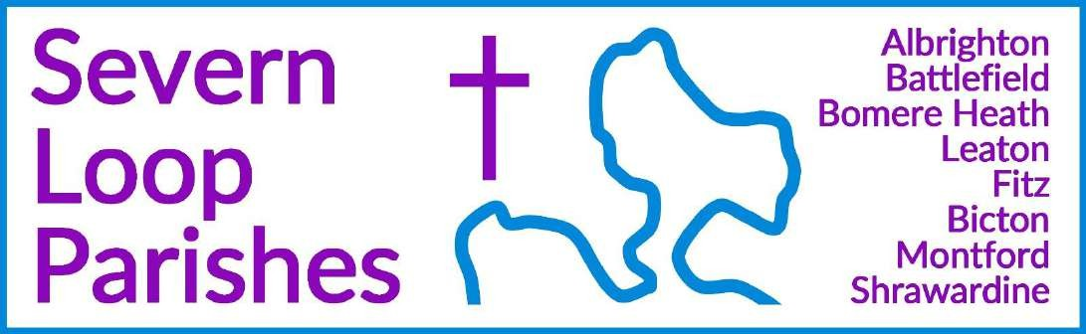
Priest in Charge: Revd Hannah Lins revhannahlins@gmail.com, 07736 012011

Assistant Priest: Curate:
Revd Peter Allan Revd David Latcham
pallan412@gmail.com, 07910 071489
rev.latcham@gmail.com, 07745 968298

Pastoral Minister: Mrs Joyce Jagger pearhill1@outlook.com, 07802 695954
Safeguarding Officer: Mrs Philippa Herbert 07871 865253
Administrator: Miss Rosie Dixon severn.loopparishes@gmail.com

Daily Hope (the national phoneline service) 0800 8048044
Weekly Collects, readings and reflections are on the website- www.severnloopparishes.org.uk

SEPTEMBER LOOP 2026


Confirmations coming up!

This month we are welcoming Bishop Sarah to Leaton on 20th September (5pm) for a service of confirmation. There are a number of adults and young people around the Loop who are preparing to make this commitment of faith, and it’s been a joy spending time with them over recent months. It’s deeply encouraging as we, as a church family, grow together and journey onwards with Christ as our strength, guide and comfort.

Some of those intending to be confirmed have not yet been baptised, so there will also be a number of baptisms coming up in the next few weeks- please do pray for all the candidates, and please do feel warmly welcome to our service on 20th September- it would be great to have folk from all around our congregations present to cheer them on!

This coming Sunday at Leaton (6th September) is a particularly special service- there will be an adult baptism, and we will also be dedicating our new votive candle stand. This stand has been purchased in memory of two members of the congregation- Ann Griffiths and Rachael Davies- and we hope it will be well-used as a focus for prayer and remembrance.

Wednesday eve Small Group
Join us on 2nd and 16th September at 7:30pm in the Mission Church, Bomere Heath.
New members always welcome! For more details contact Dave – rev.latcham@gmail.com.



Loopy Sundays – blessing backpacks! Sun 13 Sept, 3pm, Bomere Mission Church
At Loopy Sundays we want to give the opportunity to ask God to bless the new school year ahead. We’re inviting children to bring their school rucksacks to have them blessed, as part of our normal informal worship and interactive bible story.
Join us for informal worship, prayer activities, and the ever-present refreshments. Feel free to just turn up, but if you’d like to find out more in advance, do email Dave – rev.latcham@gmail.com.
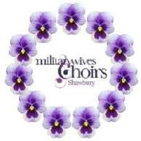
Shawbury Military Wives Choir Concert
Leaton Church
Friday 25th September, 7.30pm
Come and join us for an evening of wonderful music, light refreshments will be available.
Tickets £10
There will be a raffle, proceeds to be divided between Lingen Davies Cancer Charity and Leaton Church.

Forest Church Pet Service


Sunday, 27th September 3-4.30pm, Leaton Forest
Bring your pet along this month as we enjoy our annual pet service- giving thanks for our non-human friends and all God’s creation. All pets are welcome (including
horses!), and we are meeting by the grain store at Leaton Forest (where you buy your Christmas Tree). We will enjoy a stroll together, and some time near the river. You don’t have to bring a pet- humans without them are also most welcome! More details nearer the time, but please do save the date for now.

40% of UK adults are single, and this number is rising.
27th September – 4th October 2026 is the first ever ‘Single Friendly Church Week’ For one week, churches, leaders, and individuals across the UK are coming together to say clearly: single people at every stage of life are welcomed, valued, and included here. Whether
you've never married, dating, divorced, widowed, a single parent, or single in church, you belong at the heart of Christian communities, and not on their edges.
The Single Friendly Church website has posters, prayer prompts, a podcast, advice and even a 5-step audit for churches interested in gaining SFC status –
see https://www.singlefriendlychurch.com/single-friendly-church-week



Diary Dates
CAMEO Coffee Morning at Bicton Church- 10th September, 10.30am-11.30am.
Friends Coffee Morning in Shrawardine- 15th September
The Stepping Out Café in Bomere Heath- 30th September, 2.30pm-4pm Filling Station- 15th September, 7.15pm for 7.30pm, Knockin Assembly Rooms. Free refreshments.
REVS- 19th September, 10am-noon, Leaton Church

For Your Prayers

- For our local farmers.
- For those affected by the flash floods in Nepal and Tibet.
- For those who were injured at the Big Church Festival, and the relatives of the man who died.
- For our local schools as term begins again.
- For those in hospital, and for our NHS.
- For our various social events around the parishes.
- For those preparing for confirmation and baptism.
- The family and friends of Tony Lea, Gwen Haynes, Robert Watson, Edwina Smart, Evelyn McKay and Anastasia Lawrence.
5th September 2026 St George’s Church, Shrewsbury.
10am-3pm or come for the morning 10am-1pm
Join your voice to that of Jesus Christ as we sing the psalms. Experience the unity of the Spirit and the encouragement of God’s Word as we sing the psalms together!
Book online at www.psalmroar.org

Readings for September

DAY | PSALM | 1ST READING | 2nd READING/  GOSPEL
6th September Trinity 14 | Psalm 119  33-40 | Romans 13  8-14 | Matthew 18  15-20
13th September  Trinity 15 | Psalm 103  8-13 | Romans 14  1-12 | Matthew 18  21-35
20th September  Trinity 16 | Psalm 145  1-8 | Philippians 1  21-30 | Matthew 20  1-16
27th September  Trinity 17 | Psalm 25  1-8 | Philippians 2  1-13 | Matthew 21  23-32
4th October  Trinity 18 | Psalm 80  9-17 | Philippians 3  4b-14 | Matthew 21  33-46

SUNDAY SERVICES FOR SEPTEMBER
 | Albrighton | Bicton | Bomere Heath | Fitz | Leaton | Montford | Shrawardine
6th September Trinity 14 | 9.15 am HC | 11 am HC |  | 9.30 am MP | 10.45 am HC |  | 9.30 am MP
13th September Trinity 15 |  | 11 am MP | 9 am HC |  | 10.45 am MP | 9.30 am HC | 11 am HC
20th September Trinity 16 | 9.15 am MP | 11 am HC |  | 9.30 am HC | 5pm Confirmation | 9.30 am MP
27th September Trinity 17 |  | 11 am MP | 9 am HC |  | 10.45 am MP | 11 am HC | 9.30 am HC
 |  |  |  |  | 3pm Forest Church Pets
4th October | 9.15am HC | 11am HARVEST |  | 9.30am HARVEST | 10.45am HARVEST |  | 9.30am MP
HC- Holy Communion; MP- Morning Prayer
OTHER WAYS TO WORSHIP ON SUNDAYS- SUNDAY AT SIX 6 pm via Zoom – email Peter or Hannah to receive the link. DAILY HOPE – national phone line, see number above. LICHFIELD CATHEDRAL- www.lichfield-cathedral.org 10.30 am Eucharist

