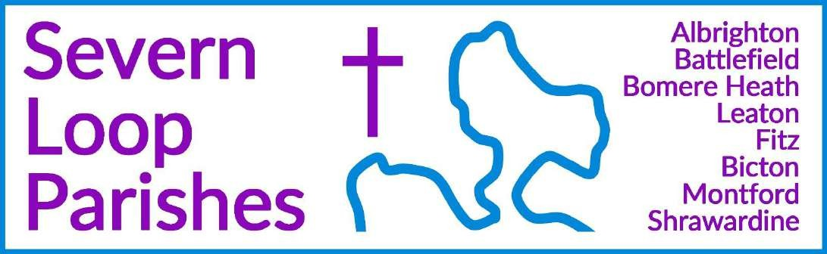
Priest in Charge: Revd Hannah Lins revhannahlins@gmail.com, 07736 012011

Assistant Priest: Curate:
Revd Peter Allan Revd David Latcham
pallan412@gmail.com, 07910 071489
rev.latcham@gmail.com, 07745 968298

Pastoral Minister: Mrs Joyce Jagger pearhill1@outlook.com, 07802 695954
Safeguarding Officer: Mrs Philippa Herbert 07871 865253
Administrator: Miss Rosie Dixon severn.loopparishes@gmail.com

Daily Hope (the national phoneline service) 0800 8048044
Weekly Collects, readings and reflections are on the website- www.severnloopparishes.org.uk

OCTOBER LOOP 2026

Harvest Time!

Our celebrations begin on Sunday! Do join us to give thanks for the abundant gifts of creation, to pray for our local farmers and our own responsibility in sharing our resources well and generously, and to worship God who sustains all our needs.

Our services are as follows- in all cases, any donations for the Foodbank would be most welcome.
4th October | 11th October | 18th October
Fitz Harvest Festival- 9.30am | Shrawardine | Albrighton Harvest Festival- 9.15am
Leaton Harvest Communion-10.45am | Harvest Festival- | Montford Harvest Festival- 9.30am
Bicton Harvest Communion- 11am | 11am


At the time of writing, the following items are in demand at the Foodbank. To get an up-to-date list, go to Shrewsbury Food Bank — Foodbank PLUS :

Dried pasta… tinned tomatoes… rice… cereal… toothpaste… soap bars…

Harvest Meals
Ecumenical Harvest Supper  Monday October 5th at 7-30pm in the Mission Church, Bomere Heath  A bring and share supper  Bring your own drinks, glasses provided | Montford and Shrawardine Harvest Lunch Montford Parish Hall  11th October  For more details, contact Tricia Jones or Esther Oates

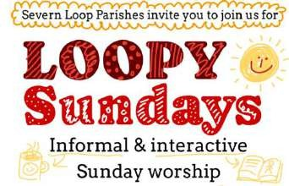
Loopy Sundays
We are meeting at 3pm on the 11th October at the Mission Church in Bomere Heath. Join us for our cafe style monthly service, with an interactive retelling of a bible story, informal atmosphere, and refreshments. Feel free to just turn up, but if you’d like to find out more in advance, do email Dave – rev.latcham@gmail.com.

Fruitfulness on the Frontline is a small group course from LICC – and it has been refreshed for 2026. Ideal for anyone wanting to discover a whole world of purpose in the everyday routine. The link to the resources is here:
bit.ly/4hjIjby
There is a £15 charge but get together a new group of 5 people or more to take the course and get a pack free from Whole Life Discipleship Officer Helen Emery helen.emery@lichfield.anglican.org

Wednesday eve Small Group
Join us on Wednesday 7th October at 7:30pm in the Mission Church, Bomere Heath, as we to study together some of the letters of the New Testament. New members always welcome! For
more details contact Dave – rev.latcham@gmail.com.


Our season of remembrance
As last year, we will begin our season of remembrance with a pet memorial service- a service that recognises this very particular kind of grief and reminds us that our pets, along with the whole of the cosmos, are held in God’s hands. Our service will be at Albrighton (25th October, 3pm), where we are surrounded by sheep and wildlife! We hope the setting will itself be a comfort. If you’d like to, please do bring along a photo of the pet/s you are remembering, and/or where a flash of purple- the colour used in remembrance to recall the animal casualties of war.

Please note, this is not a ‘Pet service’- we had that at Leaton Forest last Sunday. This is a service of remembrance for animals who have died, whom we loved.

Pet Memorial Service

25th October 3pm at Albrighton
To give thanks for our memories of the non-human friends who have been our companions down the years.

Remembering with Love

1st November, 3pm at Leaton
Our annual service to remember by those whom we love but see no longer, and to which we invite our funeral families from the past year. Do let Hannah know by email (revhannahlins@gmail.com) if you would like anyone remembered by name during the service.

Confirmations Happened!
It was a joy to welcome ten (yes, ten!) people to be confirmed by Bishop Sarah at Leaton on 20th September. Thank you to all who came along to support them- it was a joy-filled service, and such an encouragement to us all. Please do continue to keep all those who were confirmed in your prayers.
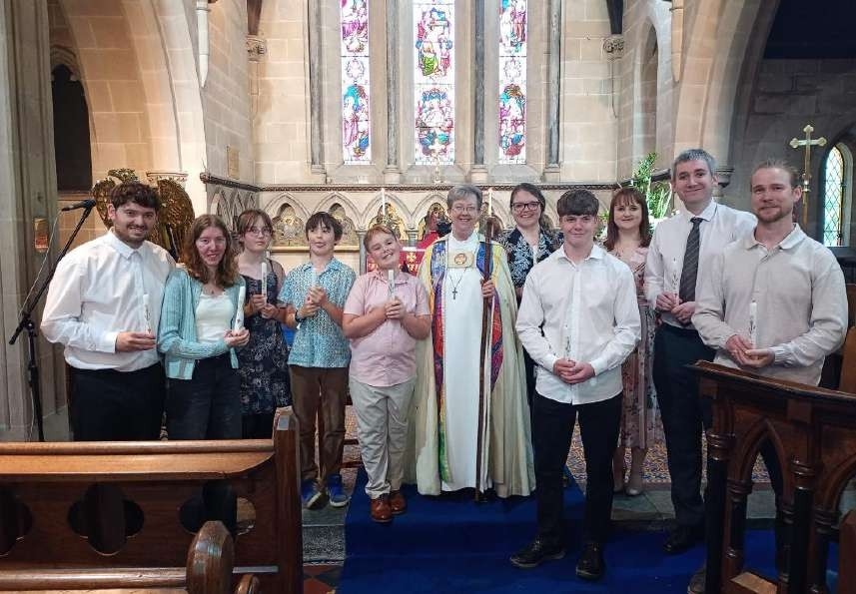

Diary Dates for October
CAMEO Coffee Morning at Bicton Church- 8th October, 10.30am-11.30am. The Stepping Out Café in Bomere Heath- 28th October, 2.30pm-4pm Shrawardine Coffee Morning- 20th October, 10.30am
Filling Station- 20th October, 7.15pm for 7.30pm, Knockin Assembly Rooms. Free refreshments.
REVS- 17th October, 10am-noon, Leaton Church

Some dates for your diary as we head into Autumn (more details in the next Loop)
8th November- Remembrance Sunday (morning services around the Loop, and our Festival of Remembrance at 5.30pm at Fitz)
22nd November- Turkey and Tinsel Lunch at Montford Parish Hall 29th November- Advent Lunch at Fitz Village Hall
29th November- Festive Forest Church at the Mission Church- this year, we will be holding a traditional children’s party with jelly and games!

For Your Prayers

- For our local farmers.
- For peace in Sudan, the Middle East and Ukraine.
- For those in hospital, and for our NHS.
- For Kirsty and Luke, getting married at Bicton on 31sst October, and for baby Florence, who will be baptised at Bicton this month.

Readings for October

DAY | PSALM | 1ST READING | 2nd READING/  GOSPEL
4th October Trinity 18 | Psalm 80  9-17 | Philippians 3 4b-14 | Matthew 21  33-46
11th October  Trinity 19 | Psalm 23 | Philippians 4  1-9 | Matthew 22  1-14
18th October  Trinity 20 | Psalm 96  1-9 | 1 Thessalonians 1  1-10 | Matthew 22  15-22
25th October  Last after Trinity | Psalm 1 | 1 Thessalonians 2  1-8 | Matthew 22  34-46
1st November  Feast of All Saints | Psalm 34  1-10 | 1 John 3  1-3 | Matthew 5  1-12

SUNDAY SERVICES FOR OCTOBER
 | Albrighton | Bicton | Bomere Heath | Fitz | Leaton | Montford | Shrawardine
4th October | 9.15 am | 11 am |  | 9.30 am | 10.45 am |  | 9.30 am
Trinity 18 | HC | HC |  | MP | HC |  | MP
 |  | Harvest |  | Harvest | Harvest
 |  | Communion |  | Festival | Communion
11th October |  | 11 am | 9 am |  | 10.45 am |  | 11 am
Trinity 19 |  | MP | HC |  | MP |  | Harvest
 |  |  |  |  |  |  | Festival &
 |  |  |  |  |  |  | Lunch
18th October | 9.15 am | 11 am |  | 9.30 am | 10.45 am | 9.30 am
Trinity 20 | MP | HC |  | HC | HC | MP
 | Harvest |  |  |  |  | Harvest
 | Festival |  |  |  |  | Festival
25th October | 3 pm Pet Memorial Service | 11 am MP | 9 am HC |  | 10.45 am MP | 11 am HC | Worshipping with Montford
1st November | 9.15am HC | 11am HC |  | 9.30am MP | 10.45am HC |  | 9.30am MP
 |  |  |  |  | 3pm Remembering with love
HC- Holy Communion; MP- Morning Prayer
OTHER WAYS TO WORSHIP ON SUNDAYS- SUNDAY AT SIX 6 pm via Zoom – email Peter or Hannah to receive the link. SHARING THE LIGHT IN THE LOOP- weekly phone line worship – see top of this page for the number. DAILY HOPE – national phone line, see number above. LICHFIELD CATHEDRAL- www.lichfield-cathedral.org 10.30 am Eucharist



