Priest-in-Charge: The Revd Hannah Lins
07736 012011 revhannahlins@gmail.com
Assistant Priest: The Revd Peter Allan
www.severnloopparishes.org.uk 01939 290048 pallan412@gmail.com
Loop Safeguarding Officer: Mrs Philippa Herbert 01939 291352 Lay Pastoral Minister: Mrs Joyce Jagger
Sharing the Light in the Loop 01743 298285 weekly worship 07802 695954 pearhill1@outlook.com
Daily Hope – the national service 0800 804 8044
JULY LOOP 2024
Weekly Collects, Readings and Reflection are on the website (see above.)

Mirfield
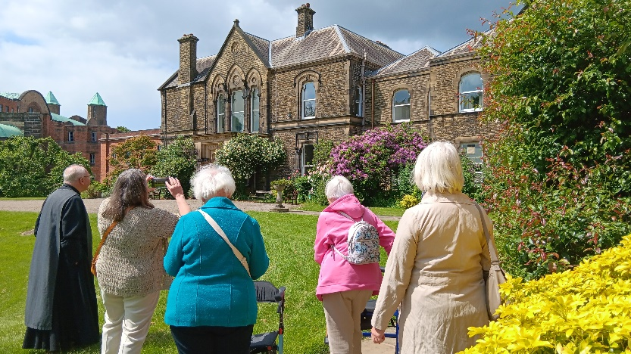
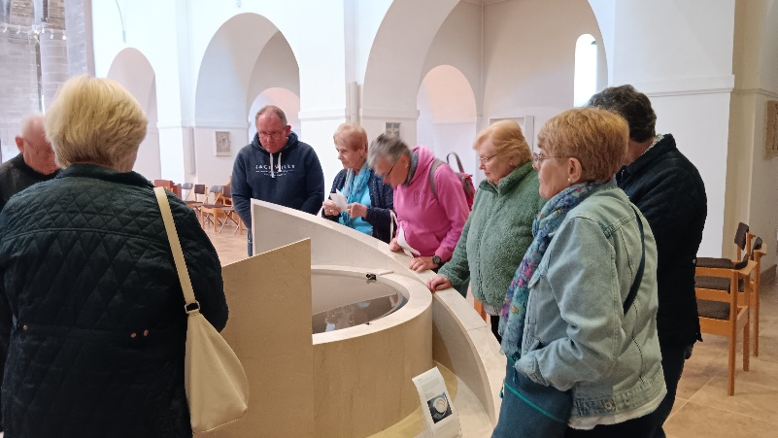
During June, two groups went to spend the day at The Community of the Resurrection, Mirfield. We joined in the rhythm of the day- which included a silent supper! A new experience for some of us… we also participated in their times of worship and prayer, and we were treated to a brilliant tour and talk from Peter. All of us were deeply moved by the story of this particular expression of monastic living, and humbled by the hospitality, thoughtfulness and peace of the brothers who welcomed us. Overall, it was a very affecting day, and one which will stay with us all. If you would like to visit the community, then have a look at their website for options- Mirfield - Community of the Resurrection - they do retreat days, but they also do Air B&B !

Forest Church
Our next Forest Church is:

Sunday, 7th July, 3pm
Pimhill Barn at Lea Hall, SY4 3DY

To get there, take the A528 to Wem. Go through Albrighton, and after a couple of miles there will be a right turn, signposted to Pimhill Barn at Lea Hall. Take that, and then further down the lane there is a left turn, which is signposted- take the turn and follow the lane up, until you reach the house. Bear left, driving past the house and dovecote on your right, and park. Do bring a picnic tea, and please leave dogs at home on this occasion.

Service Cover in July and August
We are very grateful to Revd. Andy Ackroyd and Fr. Stan Swift who will be covering services whilst Peter is at Mirfield in July. Then in August, Revd. Paul Firmin will be covering three Sundays to enable Hannah to go on holiday. Thank you! As usual, there will be no services at Fitz in August.

Battlefield Commemoration
Sunday, 21st July 2024
2pm, St Mary Magdalene, Battlefield

A local artist (Stephen Hopper) has painted a portrait of Harry Hotspur, which is going to be unveiled at Battlefield Church on 21st July at 2pm. All are welcome to come along. There will be representatives from various groups there, along with the Deputy Mayor Cllr. Alex Wagner and Anthony Rich of the Battlefields Trust. We have been asked to lead a short act of worship as part of the event, so it would be great to have some Loop-ers in attendance!

Bicton School

Mrs Natalie Johnson, Headteacher at Bicton School, will be leaving at the end of this term. A teacher at the school for many years, she is so well-known and well-respected in the community- and she has taught so many local folk! We are all so grateful for her brilliant time as headteacher- for her wisdom, patience, commitment and love for the school. She goes with our prayers and our love, and we wish her well.

The Mission Church
Work is being carried out on the Mission Church in Bomere Heath over the summer… and we’re very excited! We’re looking forward to a bigger and better equipped kitchen area, and a new toilet. Because of the disruption this will entail, the building will be out of use. This means that there will be NO Stepping Out Café in July or August, and no Sunday services in August. Thank you so much for your understanding.

Summer Craft Fair at Bicton Church
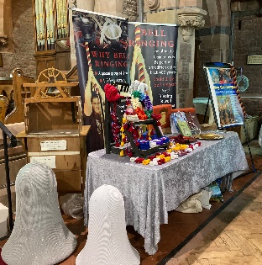
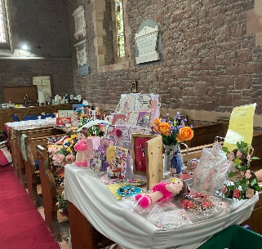
Saturday, 17th August
11am-3pm
Back by popular demand!

Sale tables are £10 (please supply your own table)- to book one, contact Clare Dixon on 01743 361906.

Diary Dates
Bicton CAMEO Coffee Morning- 11th July, 10.30am- noon. In church.
Friends Coffee Morning, St Mary’s, Shrawardine-, 10.30am.
The Stepping Out Café in Bomere Heath- CANCELLED FOR JULY AND AUGUST
Filling Station- Knockin Village Hall is on 16th July, 7.10pm for a 7.30pm start. The next one at Rodington Village Hall (SY4 4QS) is on 22nd July 2024, 7.15pm for a 7.30pm start.
Bicton Church is now open on Saturday mornings- 10am-noon- for visitors and/ or private prayer.

For Your Prayers
- For candidates in the General Election and all who are canvassing.
- For the people of Israel and Palestine and the people of Ukraine- for peace.
- For all those preparing for Baptism or to be married.
- For those in hospital, and for our NHS.
- For our year six pupils at Bomere and Bicton, as they leave primary school.
- For those enjoying holidays.

Readings for July

Date | Psalm | First Reading | Second Reading/ Gospel
7th July  Trinity 6, green | 123 | Ezekiel 2.1-5 | Mark 6.1-13
14th July  Trinity 7, green | 85.8-13 | Amos 7.7-15 | Mark 6.14-29
21st July  Trinity 8, green | 23 | Jeremiah 23.1-6 | Mark 6.30-34,53-56
28th July  Trinity 9, green | 145.10-19 | 2 Kings 4.42-44 | John 6.1-21
4th August  Trinity 10, green | 78.23-29 | Exodus 16.2-4,9-15 | John 6.24-35

SUNDAY SERVICES FOR JULY 2024

 | Albrighton | Bicton | Bomere  Heath | Fitz | Leaton | Montford | Shrawardine
7th July | 9.15 am  HC | 11 am  HC |  | 9.30 am  HC | 10.45 am  HC |  | 9.30 am  MP
14th July |  | 11 am  MP | 9 am  HC |  | 10.45 am  MP | 9.30 am  HC | 11 am  HC
21st July | 9.15 am  MP | 11 am  HC |  | 9.30 am  HC | 10.45 am  HC | 9.30 am  MP
28th July |  | 11 am  MP | 9 am  HC |  | 10.45 am  MP | 11 am  HC | 9.30 am  HC
4th August | 9.15am  HC | 11am  HC |  | NO SERVICE | 10.45am  HC |  | 9.30am  MP

HC- Holy Communion; MP- Morning Prayer

OTHER WAYS TO WORSHIP ON SUNDAYS
SUNDAY AT SIX 6 pm via Zoom – email Peter or Hannah to receive the link.
SHARING THE LIGHT IN THE LOOP- weekly phone line worship – see top of this page for the number.
DAILY HOPE – national phone line, see number above.
LICHFIELD CATHEDRAL- www.lichfield-cathedral.org 10.30 am Eucharist

