

**Priest-in-Charge:** The Revd Hannah Lins

07736 012011 [revhannahlins@gmail.com](mailto:revhannahlins@gmail.com)

**Assistant Priest:** The Revd Peter Allan

[www.severnloopparishes.org.uk](http://www.severnloopparishes.org.uk) 01939 290048 [pallan412@gmail.com](mailto:pallan412@gmail.com)

**Loop Safeguarding Officer:** Mrs Philippa Herbert 01939 291352 **Lay Pastoral Minister:** Mrs Joyce Jagger

**Sharing the Light in the Loop** 01743 298285 weekly worship 07802 695954 [pearhill1@outlook.com](mailto:pearhill1@outlook.com)

Daily Hope – the national service 0800 804 8044

**SEPTEMBER LOOP 2024**

**Weekly Collects, Readings and Reflection are on the website (see above.)**

**Equipped for Mission!**

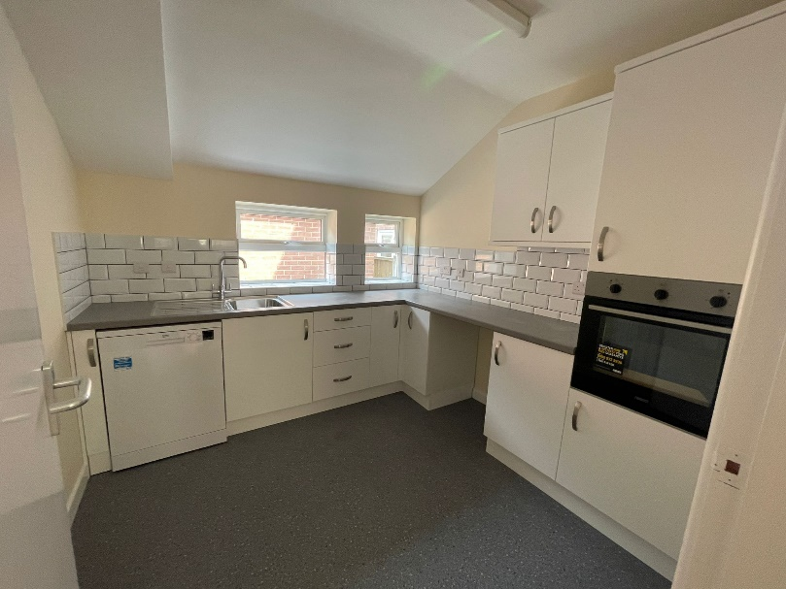

About twenty years ago there was a trend for ‘mission consultants’- people who would come into church communities and look at the things folk could do to help enable church growth. Congregations might have expected some challenging suggestions about training for evangelism, or books to read, or massive overhauls of the pews (shudder!). But actually, the most frequent answer was (drum roll)… a toilet and running water!

Here in Severn Loop that can be something of a luxury- we have four churches without either, but who still cope brilliantly- managing to provide refreshments and even hosting coffee mornings. These are such important acts of hospitality that welcome people in and show something of God’s love. Thank you.

At the Mission Church in Bomere Heath we do have both water and a toilet, but we have long been due an overhaul. Work has been underway this summer, and we are extremely thankful for some legacy money which has funded our refurbishment. As September begins we reopen with a new (and more accessible) toilet, and a bigger, better-equipped kitchen. We hope our new facilities will help us to do even more to reach out to the surrounding community and provide a good quality venue.

**Forest Church**

Our next Forest Church is:

**Sunday, 15th September, 3pm**

**Plex Stable yard SY4 3AH**

We are so excited to be holding a **pet service** for our next Forest Church! You absolutely don’t have to have a pet to come along, but do please feel free to bring your pets- up to and including horses! There is plenty of room for trailers.

To get there, take the A528 off the Ellesmere Road roundabout (signposted Wem). Go as far as Albrighton, and after the church there will be a right turn, signposted to Plex (this little lane eventually goes to Hadnall). Take that, and the stables and yard is along that lane, on the right-hand side.

**Ministry Update**

From late September Peter will be taking some time away from parish life in order to focus on his broader ministry in the Church of England, but he will be back in time to enjoy the busyness of Christmas in our churches! In the meantime we are deeply grateful to the usual suspects (!), who will be covering our services. On 22nd September one of the team from Meole Brace will be at Bomere and Leaton.

In other news, our Rural Dean- Revd. Andy Ackroyd- is moving on to pastures new. Our two assistant Rural Deans will be stepping into the breach for now- Revd. Fi Iddon and Revd. Lisa Knight.

**Ride and Stride, 14th September 2024**

The annual Ride and Stride event around Shropshire churches takes place on Saturday, 14th September. We are hoping that all of our churches will be involved- some will be providing ‘porch welcomes’ and others will be open. Please do take the opportunity to visit some of Shropshire’s historic churches and spread the word.



Bicton Church- open 11am-3pm

Leaton Church- open 10am-4pm

Montford Church- open 10am-5.30pm

Shrawardine Church- open all day

Pat and Matthew Hall (from our Leaton congregation) will also be doing their sponsored tour of the churches- so do support them if you can!

**Diary Dates**

**PLEASE NOTE THAT THERE IS NO BICTON COFFEE MORNING IN SEPTEMBER (back in October).**

**Friends Coffee Morning, St Mary’s, Shrawardine-**, 17th September, 10.30am.

**The Stepping Out Café in Bomere Heath-** 25th September, 2.30pm-4pm.

**Autumn Coffee Morning Fitz Village Hall-** 28th September, 10.30am- noon.

**Filling Station**- Knockin Village Hall is on 17th September, 7.10pm for a 7.30pm start. The next one at Rodington Village Hall (SY4 4QS) is on 23rd September 2024, 7.15pm for a 7.30pm start.

**REVS-** 22nd September, 9.30am-noon, Montford Bridge Café.

**For Your Prayers**

* For our new government and parliament.
* For the people of Israel and Palestine and the people of Ukraine- for peace.
* For Jack and Katie preparing to be married at Leaton.
* For Imogen, being baptised at Bicton.
* For those in hospital, and for our NHS.
* For the presidential campaign in the US.
* For those bringing in the Harvest.

**Prayer and Praise Evening**

Our next Loop Prayer and Praise evening will be at the Mission Church, on Thursday, 26th September, 7pm-8pm. Join us for an informal hour of extempore prayer and sung worship as we pray for the life of Severn Loop.

**Readings for September**

|  |  |  |  |
| --- | --- | --- | --- |
| **Date** | **Psalm** | **First Reading** | **Second Reading/ Gospel** |
| 1st September  Trinity 14 (Green) | 15 | Deuteronomy 4.1-2,6-9 | Mark 7.1-8,14,15,21-23 |
| 8th September  Trinity 15 (Green) | 146 | Isaiah 35.4-7a | Mark 7.24-37 |
| 15th September  Trinity 16 (Green) | 116.1-8 | Isaiah 50.4-9a | Mark 8.27-38 |
| 22nd September  Trinity 17 (Green) | 54 | Jeremiah 11.18-20 | Mark 9.30-37 |
| 29th September  Trinity 18 (Green) | 19. 7-14 | Numbers 11.4-6,10-16,24-29 | Mark 9.38-50 |
| 6th October  Trinity 19 (Green) | 8 | Genesis 2.18-24 | Mark 10.2-16 |
| *Harvest Readings* | *126* | *1 Timothy 6. 6-10* | *Matthew 6. 25-33* |

**SUNDAY SERVICES FOR SEPTEMBER 2024**

|  |  |  |  |  |  |  |  |
| --- | --- | --- | --- | --- | --- | --- | --- |
|  | **Albrighton** | **Bicton** | **Bomere**  **Heath** | **Fitz** | **Leaton** | **Montford** | **Shrawardine** |
| **1st September** | 9.15 am  HC | 11 am  HC |  | 9.30 am  HC | 10.45 am  HC |  | 9.30 am  MP |
| **8th September** |  | 11 am  MP | 9 am  HC |  | 10.45 am  MP | 9.30 am  HC | 11 am  HC |
| **15th September** | 9.15 am  MP | 11 am  HC |  | 9.30 am  HC | 10.45 am  HC | 9.30 am  MP |  |
| **22nd September** |  | 11 am  MP  12.30pm Baptism | 9 am  HC |  | 10.45 am  MP | 11 am  HC | 9.30 am  HC |
| **29th September** | United Service  10.30am |  |  |  |  |  |  |
| **6th October** | 9.15 am  HC | 11 am  Harvest Communion |  | 9.30 am  Harvest Communion | 10.45 am  Harvest Communion |  | 9.30 am  Harvest Festival |

***HC- Holy Communion; MP- Morning Prayer***

**OTHER WAYS TO WORSHIP ON SUNDAYS**

SUNDAY AT SIX 6 pm via Zoom – email Peter or Hannah to receive the link.

SHARING THE LIGHT IN THE LOOP- weekly phone line worship – see top of this page for the number.

DAILY HOPE – national phone line, see number above.

LICHFIELD CATHEDRAL- www.lichfield-cathedral.org 10.30 am Eucharist